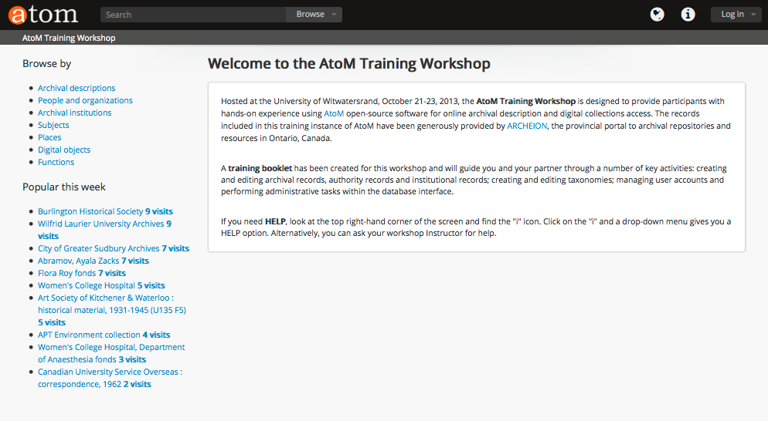
https://www.accesstomemory.org/en/

© Artefactual Systems Inc., 2013.
You are free to copy, redistribute or repurpose this work under the terms of the
Creative Commons Attribution-ShareAlike 3.0 license.

Introduction to AtoM 2.0

AtoM, stands for Access to Memory and is a web-based, free software application for standards-based archival description in a multilingual, multi-repository environment. It is designed to support International Council of Archives (ICA) standards such as General International Standard Archival Description (ISAD[G]), International Standard Archival Authority Record for Corporate Bodies, Persons and Families (ISAAR[CPF]), International Standard for Describing Institutions with Archival Holdings (ISDIAH), and International Standard for Describing Functions (ISDF). AtoM allows you to describe your archival holdings and reveal the relationships between the different entities (e.g., archival records, authority records and institution records). You will create an archival description and link it to a description of a creator and a description of an archival institution, resulting in a complete account of what the records are, who created them and which archives they belong to.

See https://www.accesstomemory.org/en/docs/2.0/user-manual/overview/intro/ for more information about AtoM.

How these Tutorials Work

This series consists of ten tutorials which are to be completed in the order listed:

1. Log in

2. Browse and Search
a) Archival Records
b) Authority Records
c) Archival Institutions
d) Functions
e) Subjects
f) Places
g) Digital Objects

3. Search & Advanced Search

4. Manage
a) Physical storage
b) Rights holders
c) Taxonomies

5. Edit and Add Archival institution
6. Edit and Add Authority record
7. Edit and Add Archival description
8. Add Accession & Deaccession record
9. Edit/Link/Import Digital objects
10. Add Terms
11. Link Physical storage

For More Information and to provide Feedback:

If you would like more detailed instructions on using AtoM in general, you can consult the online user manual at https://www.accesstomemory.org/en/docs/2.0/. If you have any comments, questions or suggestions about the tutorials, the user manual or the software itself, please email AtoM Product Manager, Jessica Bushey jessica@artefactual.com. Questions about the software can be directed to the AtoM discussion list/ community forum at http://googlegroups.com/group/ica-atom-users.

AtoM 2.0 – Authenticated Users Training Workshop

1. Log In | 4
2. Browse and Search | 6
2.1 Archival Descriptions | 6
2.2 Authority Records | 10
2.3 Archival Institutions | 12
2.4 Functions | 14
2.5 Subjects | 15
2.6 Places | 16
2.7 Digitized materials | 17
3. Advanced Search | 19
4. Manage | 24
4.1 Physical storage | 24
4.2 Rights holders | 26
4.3 Taxonomies | 27
5. Edit and Add Archival institution | 30
6. Edit and Add Authority record | 34
7. Edit and Add Archival description | 36
8. Add Accession & Deaccession record | 39
9. Link/Edit/Import Digital objects | 42
10. Add Terms | 45
11. Link Physical storage | 48

Tutorial 1 Log in
In this tutorial you will learn how to log into AtoM . To add or edit content in AtoM, you must be a logged- in user.

1.0 Start at AtoM Homepage

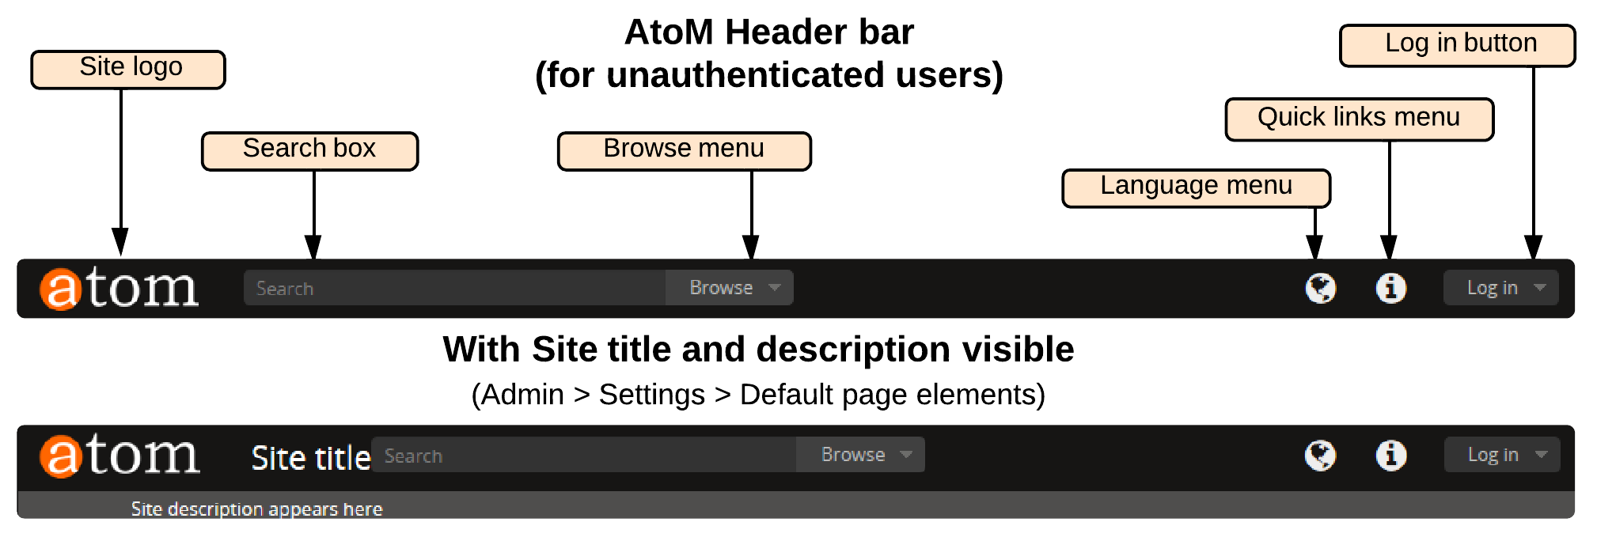

1.1 Locate the log in button in the AtoM header bar. At any time in the tutorial you can return to the Homepage by clicking on the Quick Links menu in the upper right-hand corner of your screen and selecting “Home” from the drop-down. Alternatively you can return to the homepage by clicking on the atom site logo in the left-hand corner of the header bar.

For this workshop you will log in and be granted the permissions of an Editor. AtoM provides a number of user roles with different permissions to access, edit and delete records. Assigning user roles and fine-tuning permissions and customizing the interface of AtoM is performed by an Administrator and will be covered in the second training manual. The Editor role is sufficient for performing many of the tasks assigned to an Archivist or Assistant Archivist position at an organization or institution.
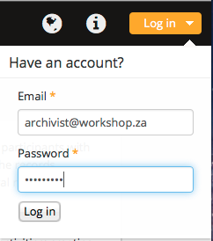
1.2 In the Log in screen enter the
following data:

1.2.1 In Email type: archivist@workshop.za
1.2.2 In Password type: archivist
1.2.3 Click the Log In button to complete

You are now logged in. Note that the your user name “archivist” appears in the right-hand corner of the screen and that you have additional icons in the menu bar. AtoM is now customized to your permissions as an Editor.

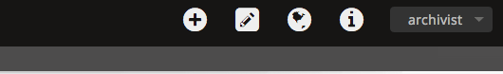

If you click on your name “archivist” in the right-hand corner of your screen, a drop-down menu gives you the choice to view your Profile or Log out. The Profile shows your permissions for Information objects (archival descriptions), Actors (authority records), Archival institutions and taxonomies. IF an Administrator has limited your permission to a single institution, the name of the institution will be shown. You will learn more about permissions in the second-day of training for Administrators.

If a time-lapse of more than 10 minutes occurs during data entry, the system will automatically log you out as a security feature. If this happens during the training workshop, simply log back in according to the instructions above.

Tutorial 2 Browse and Search
In this tutorial you will learn how to use the Browse and Search features and to navigate AtoM's menus and links.

2.0 Start at AtoM Homepage (click on atom logo in the left-hand corner)

2.1 BROWSE & SEARCH ARCHIVAL DESCRIPTIONS

Locate the Browse menu on the left-side of the screen.
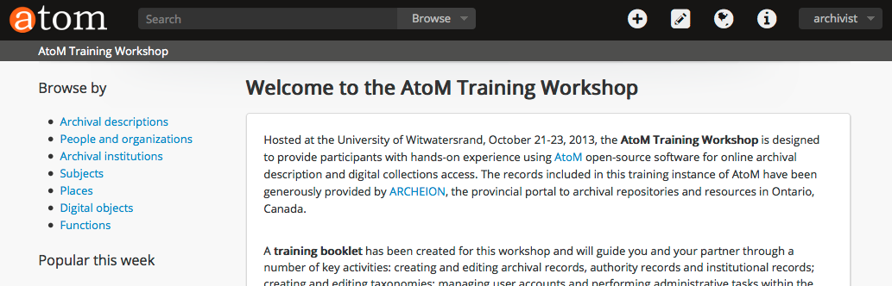
The list of resources are hyperlinks. Click on Archival descriptions
2.1.1 Atom loads the Browse results, which are sorted by the most recent (default).
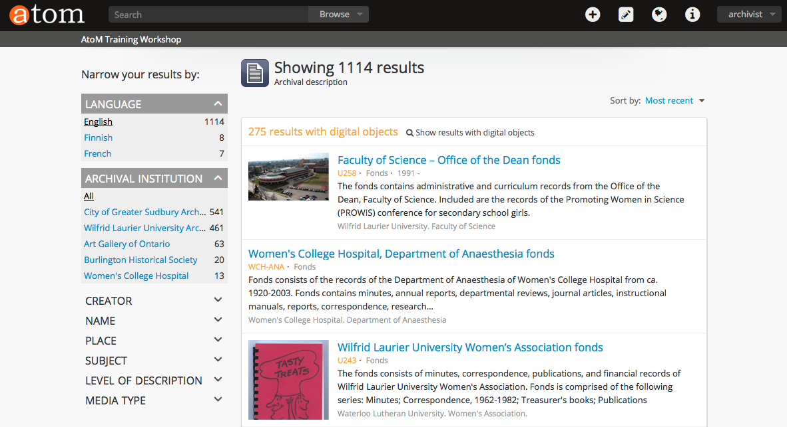
You can sort the list Alphabetically by clicking on the arrow in the “Sort by” area.

An administrator can change the default settings for both logged-in users and public users.

2.1.2 Click on a Title and you will be taken to that specific archival description.
2.1.3 Group and Narrow your Browse results with Facet filters.

In AtoM 2.0 facet filters have been introduced to allow users to group and narrow their browse and search results. A count of the records included in each facet appears next to the facet label, giving a user a sense of how many browse or search results fall under each facet.

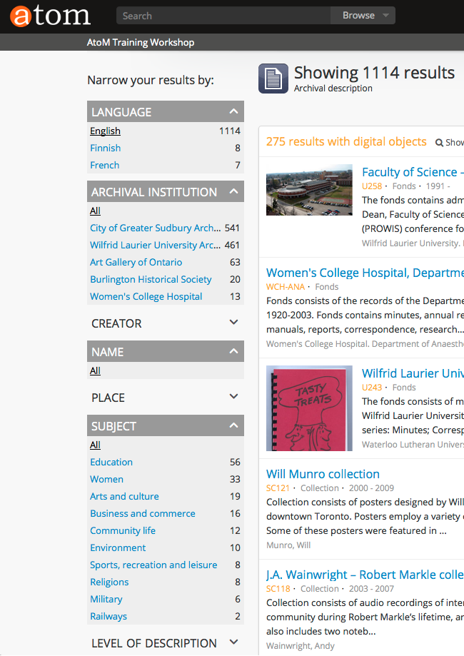
Experiment with opening and closing the arrows in the grey facet headers. You will see that there are many facet filters listed beneath the headings of Subject and Place.

If you click on any hyperlinks, AtoM will narrow your browse accordingly. For example, if you click on “Women” under the Subject Facet, AtoM will reload and and filter to show only results that match the facet filter selected. In this case, AtoM will reduce your browse results from 1114 to 33. These 33 archival descriptions reference women in their content or context.

When a facet match has been selected, the text changes from
a blue text link to black underlined text. By default all facet filters are set to “All” when a user first arrives at a browse or search screen. Clicking All will remove any previous facet filter and refresh the page results.
Try it, and you will notice that AtoM has reloaded the original 1114 results.

If “All” is the only option available beneath a facet heading, it means that there are no relevant filters in the facet that apply to the current records being displayed in the browse page.
2.1.4 SEARCH

At any time you can decide to search using keywords or boolean operators typed into the main search box (located in the header bar on all AtoM pages), including the home page. By default, when a user enters text and presses enter, the results returned are for archival descriptions. However, other record-type results can be discovered via the typeahead feature and the faceted search box results.

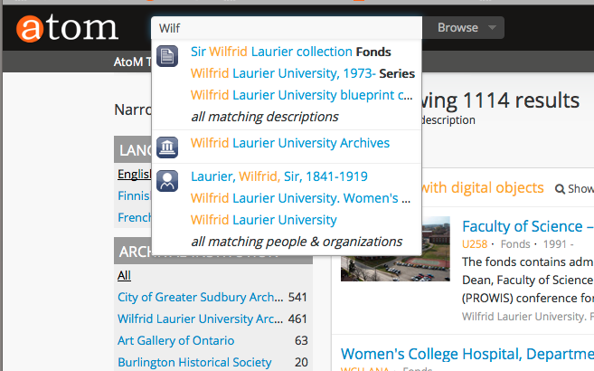
2.1.5 Start typing “Wilfrid” and you will see that the AtoM typeahead feature provides one or more matches to your search and presents them in the faceted search box results as a drop-down. Using ICONS, the first match is an archival description at the Fonds and Series and Item level, the second match is an archival repository and the third match is an authority record. These icons are used throughout the AtoM interface, so it is important to be familiar with them. The typeahead feature is set by default to begin providing suggestions only after three characters have been entered – for example, entering “a” or “an” in the search box will not prompt suggestions, but entering “ant” might produce suggestions such as an authority record for a person named “Anthony,” etc.
2.1.6 Click on the Wilfried Laurier collection Fonds and AtoM will take you to the fonds-level archival description for the Sir Wilfrid Laurier collection. The archival description is displayed according to the ISAD(G) standard. The background is yellow because the archival repository, Sir Wilfrid Laurier University has chosen to brand their institutional pages in this manner. We will discuss this further in the tutorial on editing archival institutions.
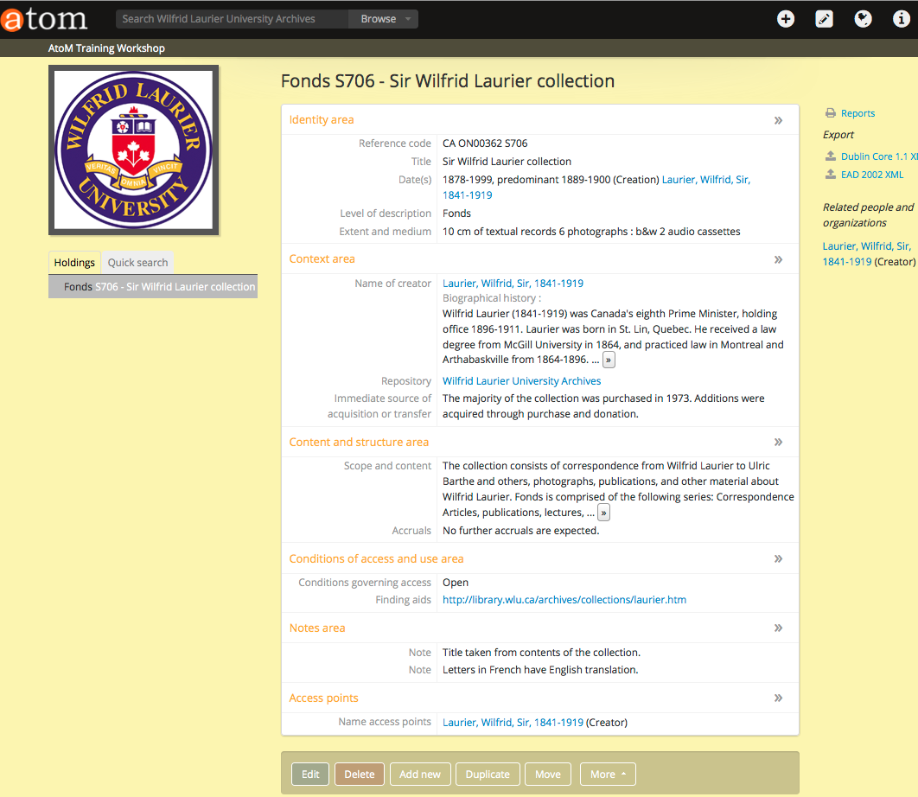

On the right-side of the screen there are a number of actions including printing a report, exporting the archival description as EAD and links to related authority records. These actions will be looked at in greater detail in the Administrator training manual. On the left-side of the screen is the treeview, which provides context for the record you are viewing. In this case, it is a fonds-level record, with no children (e.g., series, files, items).

At any time iyou can return to the homepage by clicking on the atom logo, or by clicking on the information icon and selecting home from the options. You can use the back arrow of your browser to go to the previous screen.

2.2 BROWSE & SEARCH AUTHORITY RECORDS

You can navigate to the Browse Authority Records two different ways:
- Click on the Browse tab next to the search bar at the top of the screen and select “People and organizations” from the drop-down list.
- Go to the homepage (click on atom logo in left-hand corner) and on the left-side of the screen under the Browse by heading, you can click on the “People and organizations” blue text link.
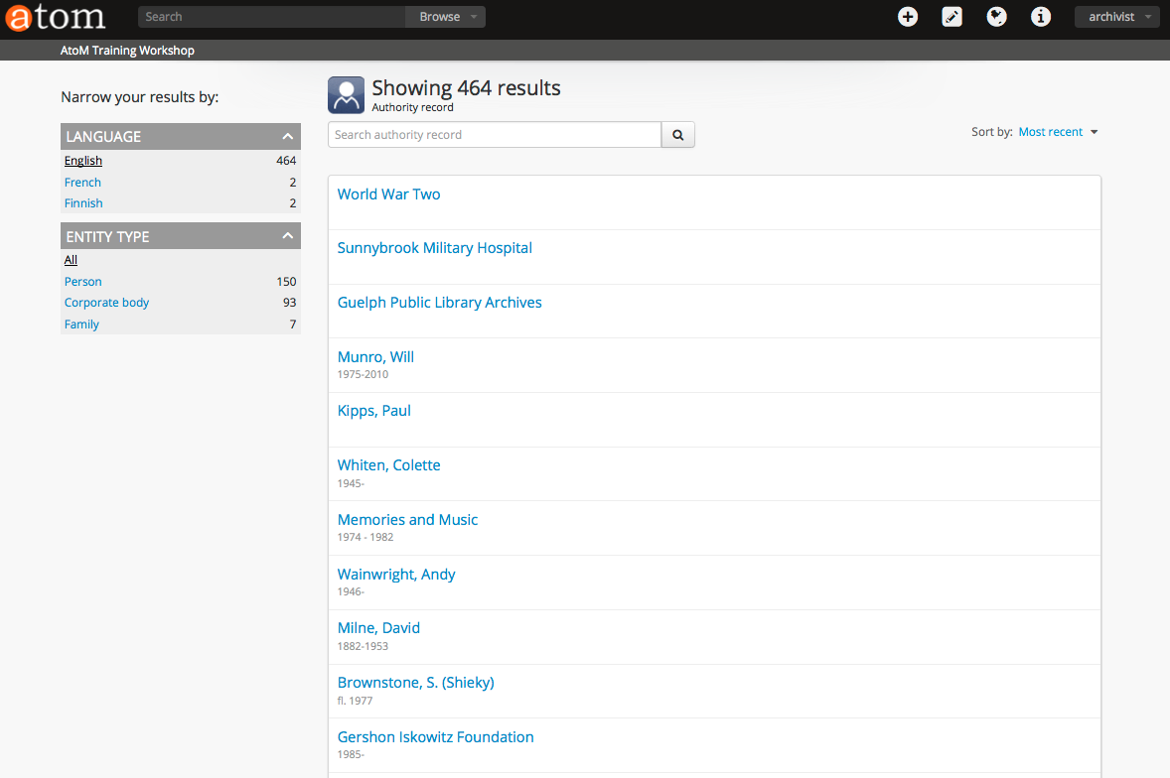
2.2.1 Review the Browse Person/organization page. By default, the Browse results are displayed 20 at a time and sorted in the order of most recent. You can sort the list Alphabetically by clicking on the arrow next to “Sort by” located in the top right-hand corner of the screen and selecting Alphabetic. You will see that AtoM sorts numbers first, then the letter A, B, C...
Notice the facet filters on the left-side of the screen. Entity types are from ISAAR and clicking on one causes AtoM to reload and narrow the result according to your selected filter.

2.2.2 Click on Abramov, Ayala Zacks and you will be taken to the Authority record for that specific person. Alternatively, if the list was pages and pages long, but you knew the name of the person, corporate body or family that you were browsing for, you could type Abramov into the search authority record bar in the main window.
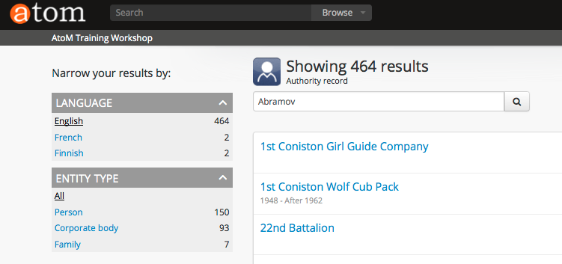
The search bars provide an effective method of quickly finding authority records instead of using the general search bar, which presents results in the context of the entire database.
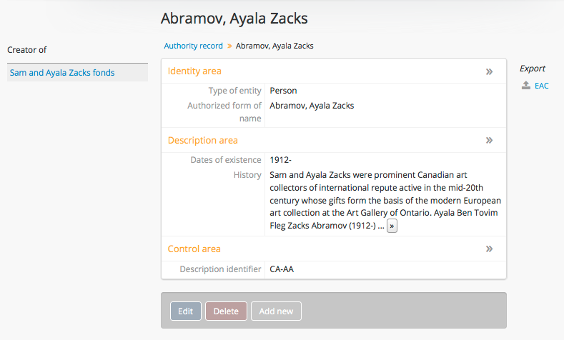

The information in the authority record is presented according to ISAAR (CPF) the ICA standard. Notice that under subheading History: you can click on the ellipses to expand the text and read more about Ayala's biographical history.

In the left-hand side of the screen there is a hyperlink to the archival fonds that Ayala Zacks Abramov is related to.

Because you are logged-in as an Editor you have access to Edit, Delete and Add new buttons. If you log-out and navigate to the same authority record, you will not see these buttons. Remember to log-in again as “archivist” to continue the workshop.

2.3 BROWSE & SEARCH ARCHIVAL INSTITUTIONS

Navigate to the Browse menu and select Archival Institutions

2.3.1 The Browse archival institution page displays thumbnails of the institution's logo, or in the absence of a logo a Title is presented.
The default view for logged-in users is “most recent”. You can sort the list Alphabetically by selecting the arrow and clicking on Alphabetic. Notice the facet filters on the left-side of the screen. The archive type is taken from ISDIAH the ICA standard.
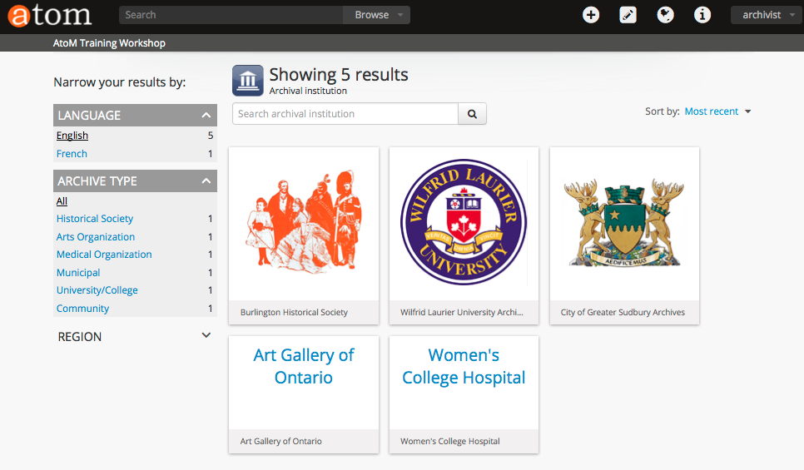

2.3.2 Click on “Burlington Historical Society” and you will be taken to the Repository view page for that specific institution. Alternatively, if the list of institutions was pages and pages long, but you knew the name of the institution that you were browsing for, you could type Burlington into the search archival institution bar in the main window.
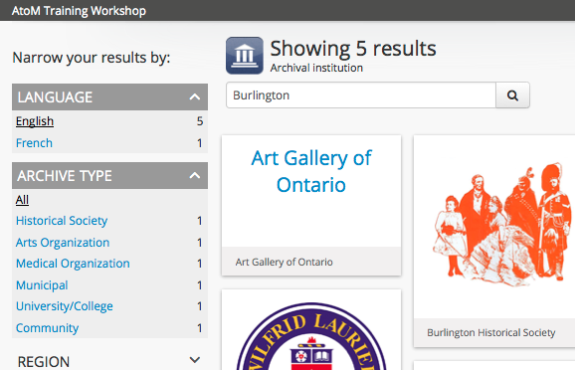

The search bars provide an effective method of quickly finding archival institution records instead of using the general search bar, which presents results in the
context of the entire database.

2.3.3 The archival institution view page presents the information about the archival institution according to ISDIAH the ICA standard. If you click on the ellipses, AtoM will expand those areas.

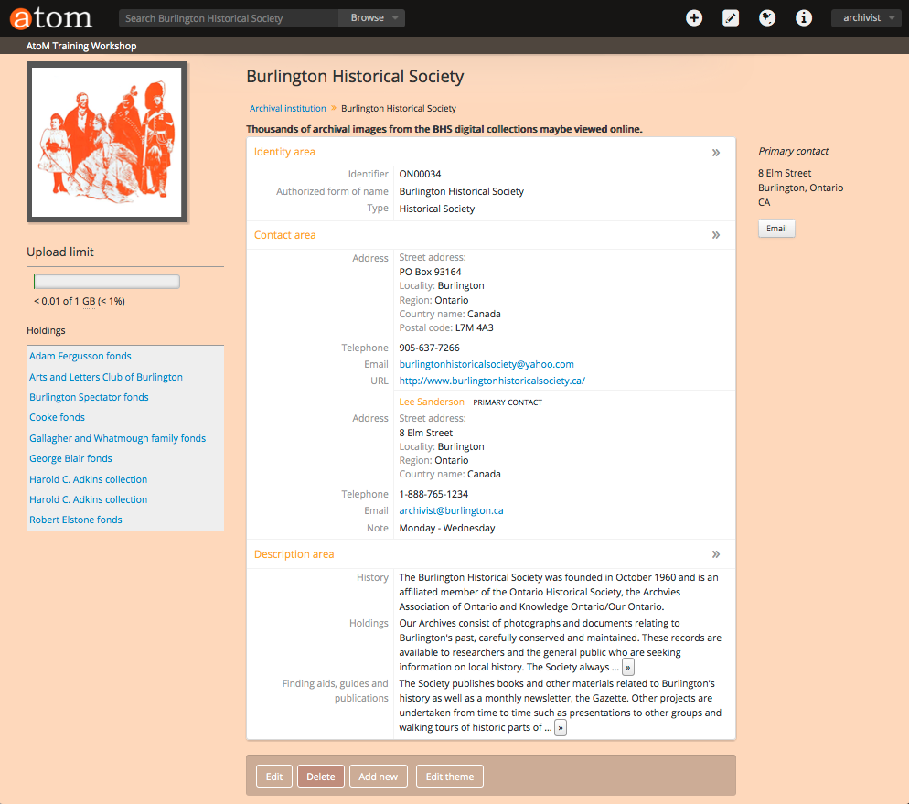
The left-side of the screen provides information about the upload limit, which means how many digital objects (e.g., images, pdfs, video and audio files) can be uploaded into the database. This limit is set by the Administrator. The holdings within the archival institution are shown on the left-side of the screen. Clicking on the hyperlinks will take you directly to the view archival description page for each fonds. Notice that the treeview is used differently on the archival institution page than on the view archival description page. In this context it provides an overview and access to ALL holdings in the repository; whereas, the treeview provides an overview and access to the levels within a specific archival description.

2.4 BROWSE FUNCTIONS

Navigate to the Browse menu and select Functions.

2.4.1 In general, corporate bodies utilize functions; therefore, your institution may not include archival holdings that require the functions feature.

“Functions are often transferred from one corporate body to another. Therefore, it will be much more difficult for the users to reconstitute the context of records creation, if they are only provided with authority records describing corporate bodies that performed the same function. Separated but linked descriptions of functions can improve the understanding of that context and can be used in conjunction with descriptions and authority files as a tool for efficient retrieval of archives and creators descriptions in archival descriptive systems.” [ISDF 2008]

The default view of Browse Functions is “most recent”. You can sort the list Alphabetically by selecting the arrow and clicking on Alphabetic.

2.4.2 Click on “Membership registration” and you will be taken to the View ISDF function page for that specific function. Alternatively, if the list was pages and pages long, but you knew the name of the function that you were browsing for, you could type Membership into the search function bar in the main window.

In the Relationships area you can view related Functions, Authority records and Archival descriptions. In this example, there is only one related Archival description.

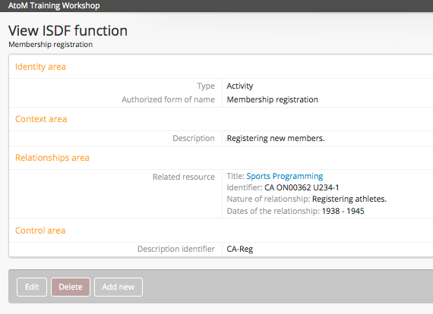

2.5 BROWSE SUBJECTS
Navigate to the Browse menu and select Subjects.

2.5.1 Review the Browse Subjects page, presented in alphabetical order. There is a pager at the bottom that can be used to move forward and backward. There is a “manage taxonomy” button available for Editors to quickly add a new subject to the list. We will add a term later in the training workshop.

2.5.2 Click on “Buildings and structures” and you will be taken to the Browse Subjects Buildings and structures page. A list of all relevant archival descriptions with the subject term “buildings and structures” are presented. The title of the collection or fonds is presented in hyperlink text along with dates, a brief description, a digital object if available, and the name of the creator. On the left-side of the screen there are Facet filters that help to narrow your search further. We will review the “manage term” button later in the training workshop.

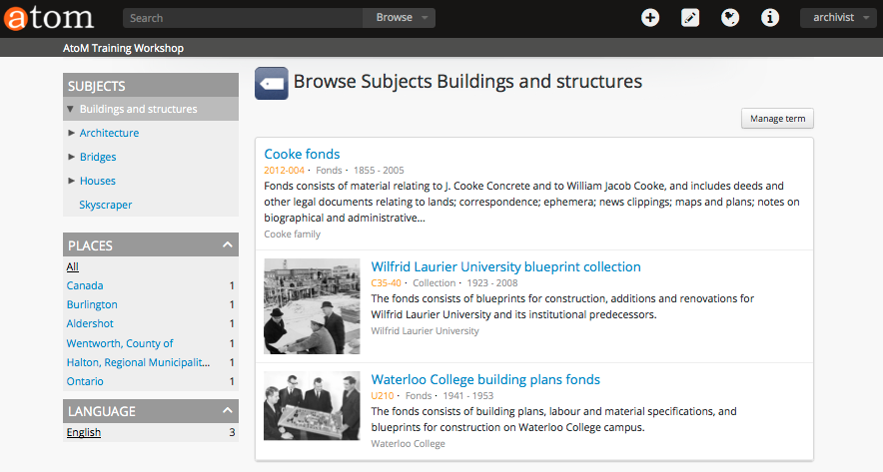
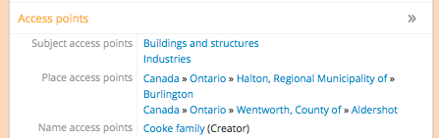
2.5.3 Click on any of the Titles and you will be taken to a View archival description screen for the relevant resource. If you scroll down to the bottom of the page you will see a section called Access points. Notice that Transportation is included in the list of Subject access points.

If you click on a different subject access point it will take you to a list of all archival descriptions which include that specific subject term.

2.6 BROWSE PLACES

Navigate to the Browse menu and select Places.

2.6.1 Review the Browse Places page, presented in alphabetical order. There is a “manage taxonomy” button available for Editors to quickly add a new place to the list. We will add a term later in the training workshop.

2.6.2 Click on “Toronto” and you will be taken to the Browse Places Toronto page. A list of all relevant archival descriptions with the places term “Toronto” are presented.

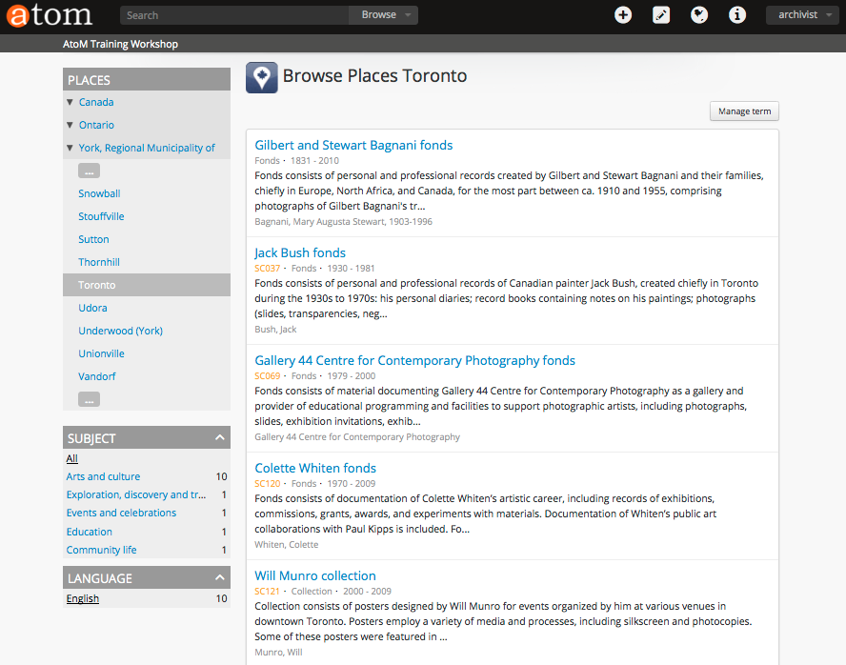
2.6.3 Click on any of the Titles and you will be taken to a View archival description screen for the relevant resource. If you scroll down to the bottom of the page you will see a section called Access points. Notice that Toronto is included in the list of Place access points.

In some cases the hierarchy is shown: Canada > Ontario > York, Regional Municipality > Toronto. If you click on any of the places in the hierarchy, for example, “Ontario”. AtoM will reload and present a Browse Places Ontario page.

2.7 BROWSE DIGITAL OBJECTS

Navigate to the Browse menu and select Digital Objects.

2.7.1 Review the Browse Digital objects page. In the right-hand corner of the screen there is a selection of different types of digital objects: Image, Text, Video and Audio. These work as Facet filters, and if you select one, AtoM will reload the page and limit the results to your selection. You can always click on “All” to return to the Browse digital objects page.
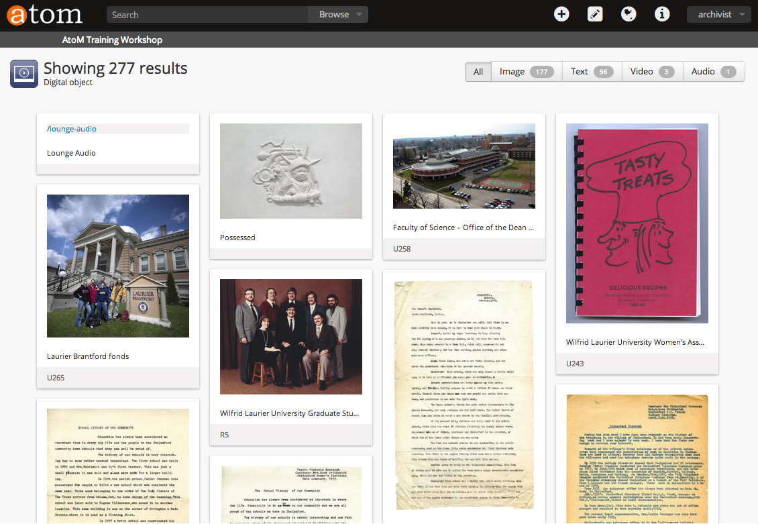
2.7.2 Click on “Image” and view the Digital object page. AtoM presents the images in the database as thumbnails. These thumbnails are automatically generated when you import or link a digital image. These activities will be discussed later in the training manual.

2.7.3 Click on any thumbnail that has the term “Accidents” in the title. AtoM loads the view archival description page. Note that the images belong to the City of Greater Sudbury Archives.

2.7.4 Navigate to the File-level description (if you are not already there) using the treeview on the left-side. You will see “Holdings” and beneath it a treeview of the Fonds, Series, File and Items. Click on “File 3- Accidents”. AtoM will reload and present the File-level description.

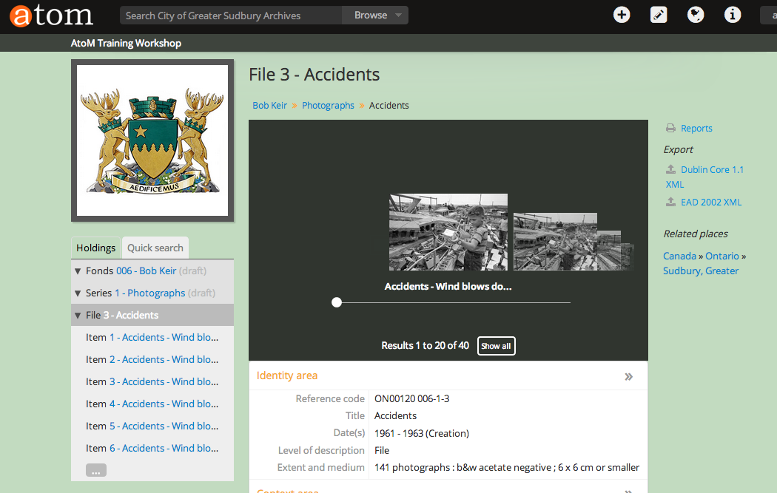
2.7.5 A cover flow viewer is presented in the centre of the screen. You can move the slider from left to right and view thumbnails of all the images included in that file. Alternatively, you can select the “show all” button and AtoM will reload and present all 40 images in the file as a single screen of thumbnails.

2.7.6 You can click on a thumbnail and AtoM will load an item-level description for that image.

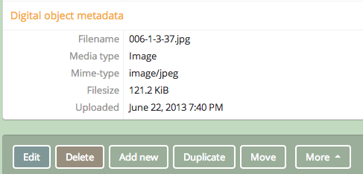
2.7.7 Notice that the item-level archival description has a section for Digital object metadata. This is information that is automatically captured during upload or linking a digital image to the AtoM system.

Tutorial 3 Search & Advanced Search
In this tutorial you will learn how to perform a general Search on the database and how to perform an Advanced Search.

3.0 Start at AtoM Homepage (click on atom logo in left-hand corner)

3.1 The search box is the primary means to find archival descriptions in AtoM that contain text matching your search query. The search box is located in the header bar on all AtoM pages, including the home page.

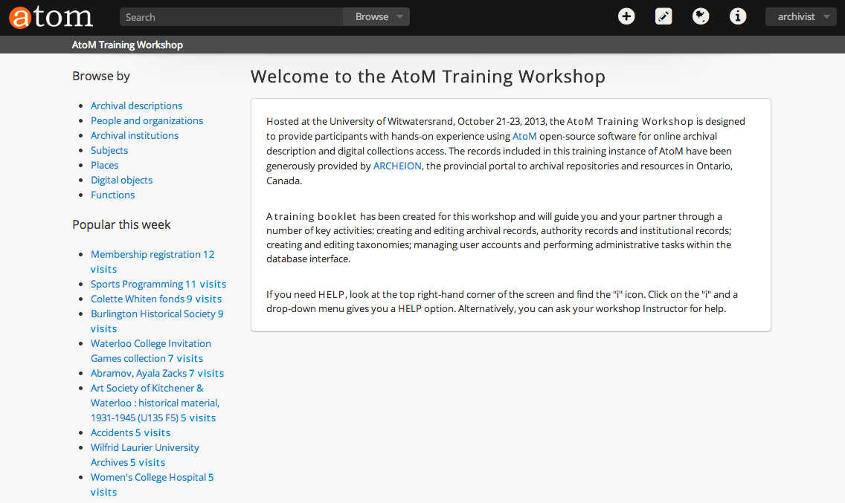
3.2 Click in the search box, and because you are on the homepage the Global Search option is the default, this means that you are querying the entire database.

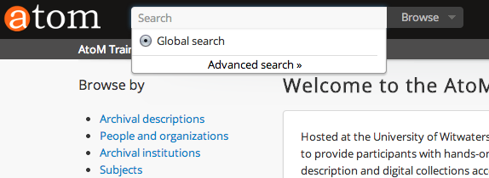

3.3 Type student records into the search box and hit enter. By default pressing enter after entering a query into the search bar will load a results page for archival descriptions only. You should have a search results page of 1100 results.

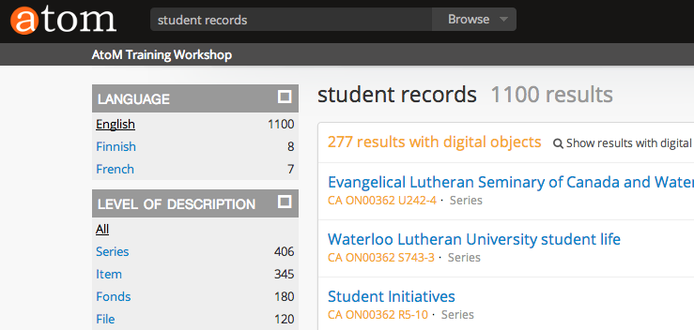
Search terms entered into the search box are, by default, searched with an “or” operator. So searching for 'student records' would by default search for student or record.

3.4 Type “student records” (using quotation marks) in the search box and press enter. You will receive one result, the only archival description that perfectly matches. You can use a number of different boolean operators in the search box.

You might have noticed that when you were typing in the search box that AtoM presented the typeahead feature, which suggests one or more possible matches to the text a user enters. The matches are presented in a drop-down below the search box, and will narrow as the user continues to enter more text. The search box typeahead results are organized into record-type categories (or facets) including: archival description, authority record and archival institution.
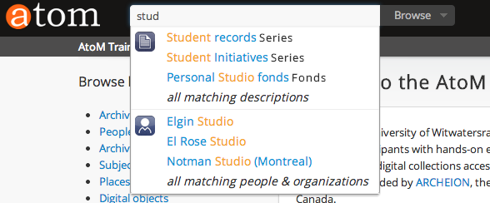

3.5 Click on the atom logo and return to the homepage. Type 'col' into the search bar. When multiple results for a record exist the typeahead drop-down includes an option to view all records for a particular type. Keep typing until you have 'colette' and select the authority record (the ICON that looks like a person) not the archival description record. AtoM will reload and take you to the authority record view page for Colette Whiten.
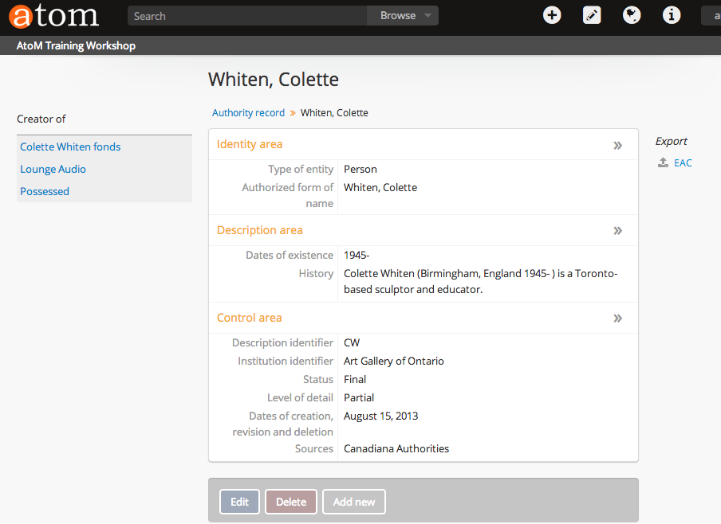

3.6 Another new feature is the ability to limit a search to holdings held within a specific archival institution, instead of searching the entire database. This is called the institutional search box delimiter feature. Go to the browse tab at the top of the screen in the header bar. Click on Browse and select Archival institutions from the options.

3.7 Select/Click on Women's College Hospital from the browse archival institution page. AtoM will reload and take you to the homepage for that specific archival institution. Notice that in the search bar at the top of the page, the name of the archival institution is there. If you start to type into the search bar, the default is set to search within that specific archival institution.
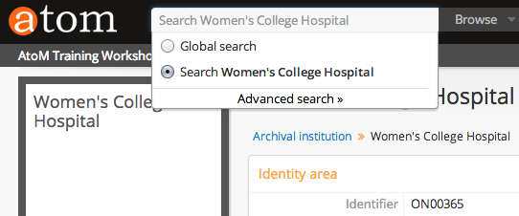

3.8 Type student records into the search bar and you will see that the only match provided is an authority record. This is because the institutional search box delimiter is set and that means only archival description records that are in the holdings of the Women's College Hospital can be searched. If you type medicine you will see that three different archival descriptions are matched in the search box drop-down. That is because they are included in the holdings of the Women's College Hospital.

3.9 To search outside of the Women's College Hospital, all you have to do is click on the radio button next to “Global search” and the search bar now has the word search in it. If you start to type a search term into the search bar, for example Stu you should get the screen below.

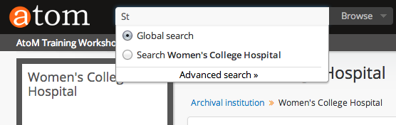

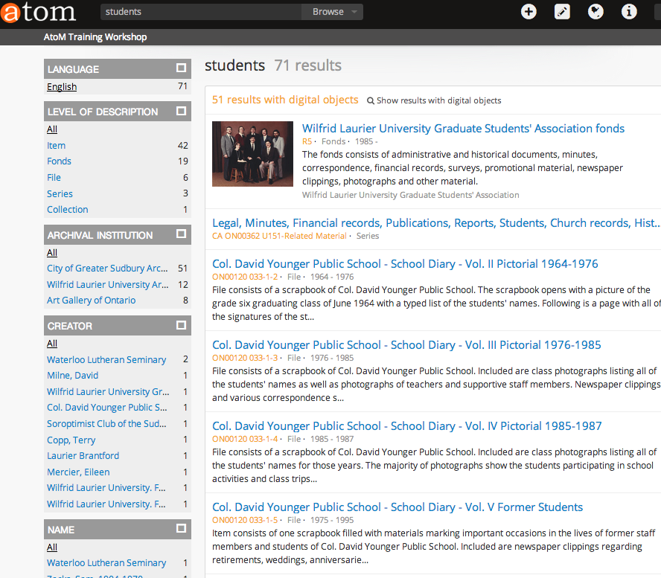
3.10 Type Students and press enter, AtoM reloads the page and provides you with a browse page of archival descriptions in the database that match your search term.

Notice the Facet filters on the left-side of the screen. You can click on any of the Facet filters to narrow your search further. Scroll down and you will see that you can narrow your search by Language, Level of Description, Archival Institution, Creator etc...

This is a powerful method of narrowing your search to find exactly what you want.

3.11 Advanced Search is another method of narrowing your search.

Navigate to the Homepage and click on the search box in the header bar at the top of the screen and select “Advanced search” from the choices.
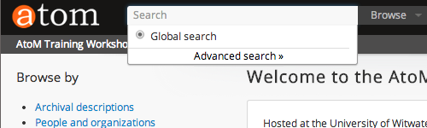

3.12 AtoM will reload and present you with an Advanced Search screen. On the left-side of the screen you see a list of Facets that can be opened by clicking on the double arrows.
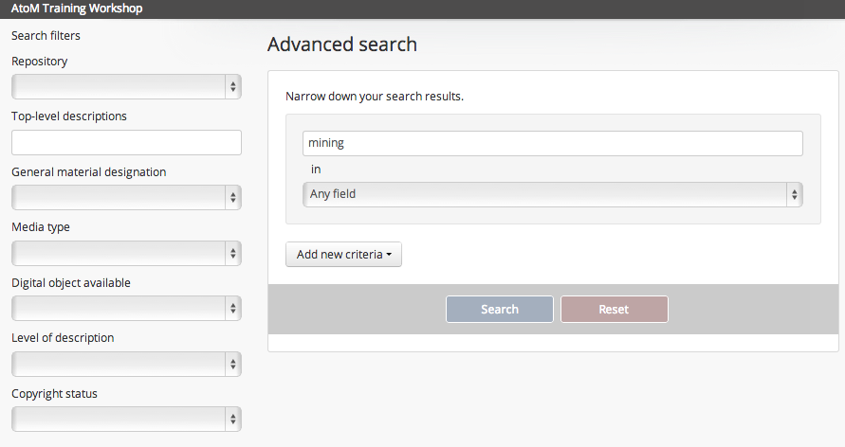
3.13 Type mining into the Advanced search box and click the search button.
You should get 35 results in the database.

Go to the Digital object available facet and select YES from the drop-down and click the search button again. You should get 28 results.

Click on the Add new criteria button and select NOT from the drop-down and then enter nickel into the search box and click on search button. You should get 3 results.

Locate the Copyright status facet and select UNDER COPYRIGHT and click on the search button. The remaining result is: Stevens Family Home Movie. View the record by clicking on the hyperlink title text.
Tutorial 4 Manage
In this tutorial you will learn how to Manage your Physical Storage, Rights Holders and Taxonomies. The general public does NOT have access to this menu.

4.0 Start at AtoM Homepage

4.1 MANAGE PHYSICAL STORAGE

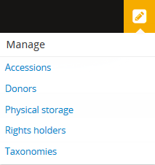
4.1.1 Navigate to the header bar at the top of the page and you will see the Manage menu, a pencil icon.
Click on the pencil icon and the Manage menu opens
to present a list of options. Select Physical storage.

The Manage menu allows authenticated users access
to a browse list of options. Once an option is selected,
the user is redirected to a browse page.

The Manage menu is distinct from the Browse menu,
which we already covered in an earlier tutorial because
it provides access to pages that are only available
to authenticated (i.e., logged-in) users.

4.1.2 The purpose of Managing Physical storage is to provide the archivist with an overview of the physical location of archival holdings within the archival institution. The list can be organized by Name or Location, simply click on the hyperlink text at the top of the columns.
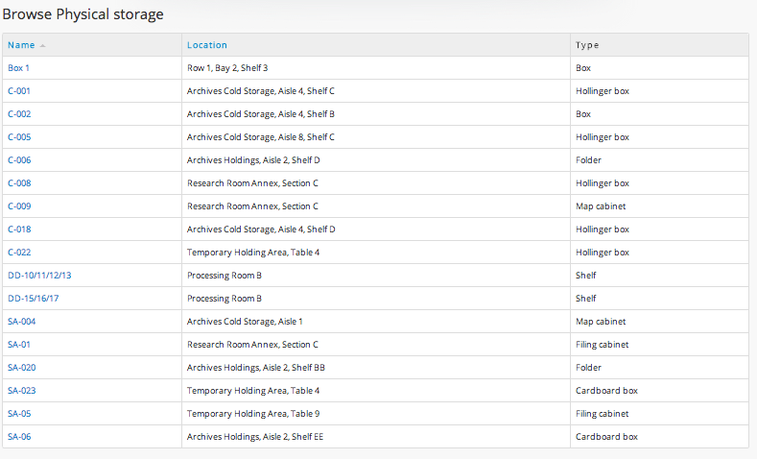

Click on SA-06. AtoM loads the View Physical storage page.
Any and all records that are physically stored in the same physical unit are listed together.

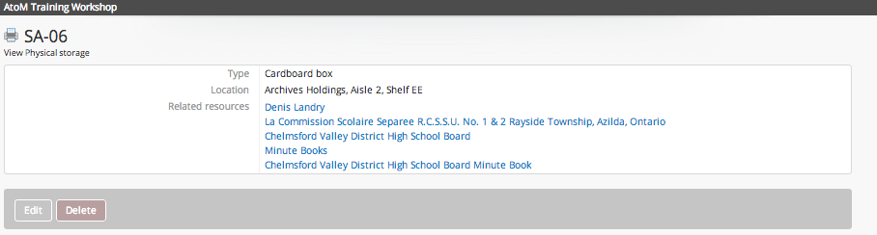
If you click on any of the Related resources you will be taken to the related View archival description page. Click on the Denis Landry link and view the archival description for that fonds. On the right-side of the screen you will see a Physical Storage section, Click on the SA-06 link. AtoM returns you to the View physical storage page.

In the top left-corner of the window you will see a small printer icon. Click on the printer icon. AtoM loads the Physical storage PRINT PREVIEW. This is helpful for archivists that want to print box lists etc.

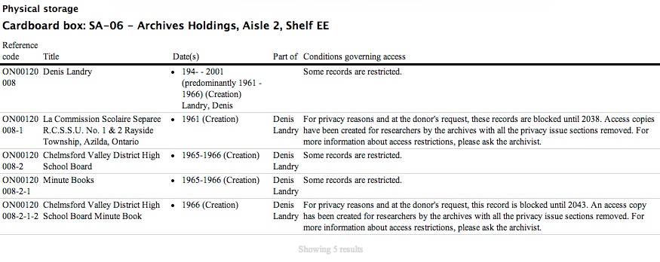

Printing and reports will be covered further in the Administrator Training Manual.

4.2 MANAGE RIGHTS HOLDERS

Navigate to the header menu at the top of the page and you will see a pencil icon = Manage menu. Click on the pencil icon and the Manage menu drops down, select Rights holder from the list. Sort by Alphabetic.

AtoM provides archivists with the ability to link Rights records to accession records, archival descriptions and digital objects. The rights are based on PREMIS and include Copyright, License, Statute, Policy, and Donor. The general template (below) is available in the Rights area of edit templates for accession records, archival descriptions and digital objects. You can see the field for the Rights holder name.
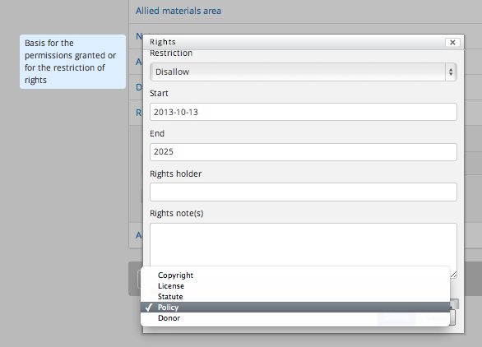

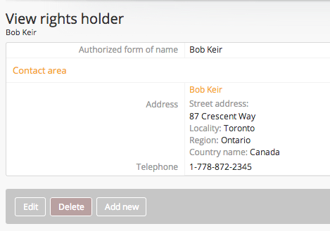
4.2.1 In the page you are viewing, there are 6 rights holders in the database. There is a search box specific to rights holders in the top-left corner of the window. If there were hundreds of rights holders, the search bar provides a effective method for quickly locating a specific rights holder from within a large dataset.

All the rights holder names are hyperlinks,
click on “Bob Keir” and AtoM takes you to the contact information for that specific rights holder. In some cases the rights holder may be the creator, the donor, a photography studio, a department, a records manager or the legal representative for a corporation.

4.3 MANAGE TAXONOMIES

Navigate to the header menu at the top of the page and you will see a pencil icon = Manage menu. Click on the pencil icon and the Manage menu drops down, select “Taxonomies” from the list.

There are 26 taxonomies in AtoM 2.0. A Taxonomy in AtoM is defined as: A grouping of controlled-vocabulary terms used to generate value lists and access points.
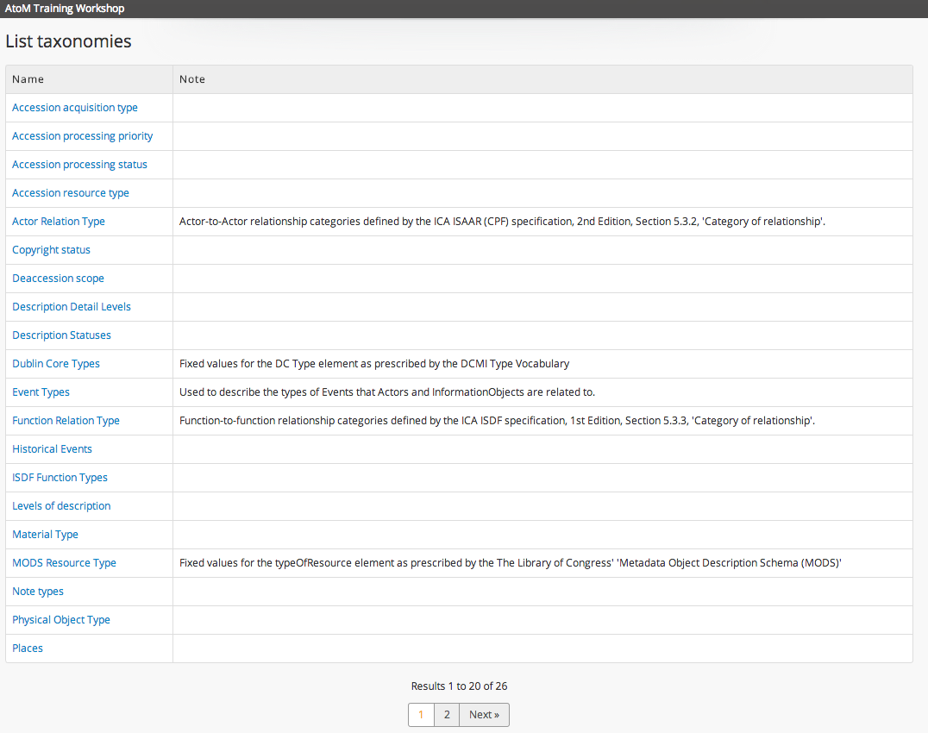

4.3.1 Throughout AtoM these taxonomies generate drop-down lists. Many of the taxonomies restrict data entry into certain fields, for example the Copyright taxonomy provides a list of terms that can be accessed in the rights interface. Click on the hyperlink “Copyright”.

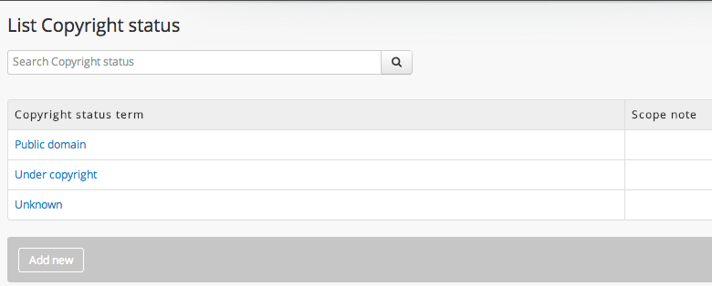
4.3.2 You are now viewing the Copyright status taxonomy. Click on the add new button and in the Name text field enter Creative commons. Now click create. AtoM reloads the page and presents a new type of copyright status, Creative commons. This taxonomy is updated throughout the database. To check, navigate to the header menu and click on the search bar, select the advanced search. Navigate to the bottom left-side of the screen where the Copyright Facet is and click on the arrows, you will see that Creative commons is now a choice for narrowing your search, whereas earlier in the training workshop the options were limited to Public domain, Under copyright and Unknown.

In many cases the taxonomies are locked and cannot be changed without altering the application's underlying code.

4.3.3 The Subjects and Places taxonomies can also be reached through the Manage taxonomy list. In AtoM 2.0 there are two different methods for locating these taxonomies and adding new terms to them.

The first method is go to the Manage menu and select from the List of taxonomies, as you have already done with the Copyright status taxonomy. To review this method, click on the hyperlink text Places at the bottom of the List taxonomy page. AtoM will reload and present a List of Places page.

The second method requires going to the Browse menu (located on the homepage or as a menu in the header bar next to the search box) and selecting Places. AtoM will reload and present a list of 18 Places currently used in the database and the number of times they are linked to a record. If you want to Manage the Places taxonomy, you must click on the Manage taxonomy button in the top right-hand corner of the window.
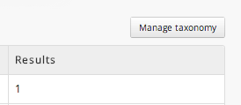

AtoM loads the List Places taxonomy page and you will see at the bottom that there are over 2000 place names available to be used in the database. If you click on the first name on the list, AtoM takes you to the term edit page, which includes a Google map location (made possible by entering longitude and latitude data).

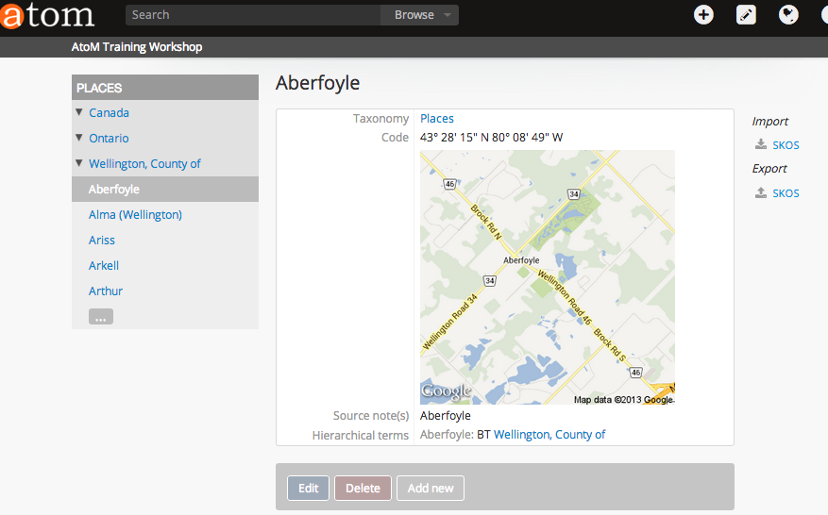
4.3.4 On the left-side of the screen you have treeview of the places hierarchy. Aberfoyle is located in the County of Wellington, which is located in the Province of Ontario, which is located in the Country of Canada.

To navigate up and down the treeview hierarchy, you click on the arrows to open and close them. Opening the arrows reveals the child-levels nested below. Clicking on the ellipses at the bottom of the treeview shows more places in the set.

The treeview is tricky at first, but you learn how to use it quickly.

Tutorial 5 Add/Edit Archival Institution
In this tutorial you will learn how to Add and Edit an Archival Institution using the ISDIAH standard compliant template.

5.0 Add Menu – Select Archival institution
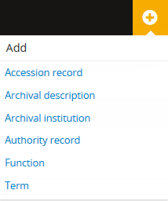
5.1 Navigate to the header bar
and click on the Add menu icon +

The Add menu's options will
redirect users to a blank record
template in edit mode, ready
for data entry. This menu is only
available to authenticated users.

For this tutorial, select Archival
institution from the list of options.

AtoM will load a new page: Edit Archival institution - ISDIAH

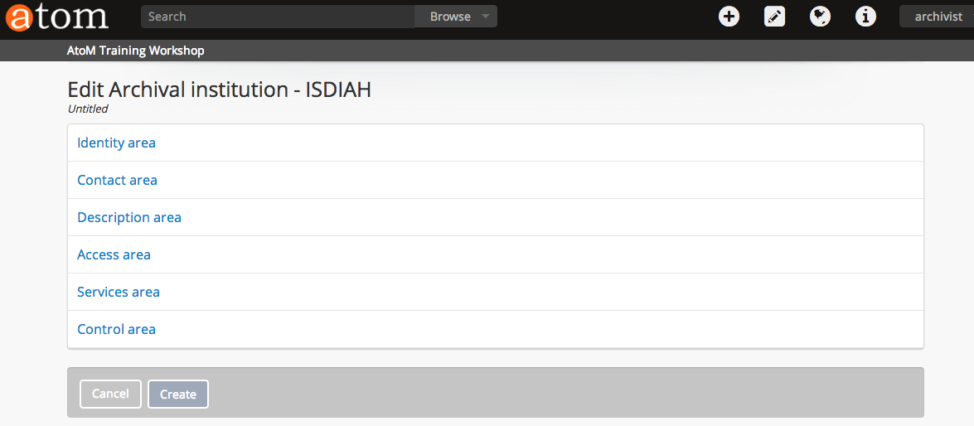
In the following exercise you will learn how to create a new ISDIAH compliant record for an archival institution, “Western Cape Archives”. Each step is explained and all the required data is provided for you. Once you are comfortable with the process feel free to input any additional data into fields that are not included in this exercise. As you enter data, grey help text (i.e., tooltips) will appear with the ICA standard rules to guide archivists.
5.2 Start at the top of the Edit Archival institution – ISDIAH template and click on the Identity area label to open that section.

- Identifier enter the following data: WCA (acronym for Western Cape Archives).
- Authorized form of name enter the following data: Western Cape Archives
- Type select from the drop-down list: Provincial/state

Be patient, working with drop-downs in AtoM takes some practice. If you make a mistake you can always delete the data in a specific field hovering over the bullet point until it turns into an “x”, then click on the “x” and delete that data. Re-enter new data.

- Click on the Create Button

If you are taking a long time to enter data, you might want to click on the Create button at the bottom of the page to make sure the browser does not time-out and lose your data. Once the archival institution's record is created, you will click on the Edit button and continue adding information into the record template.
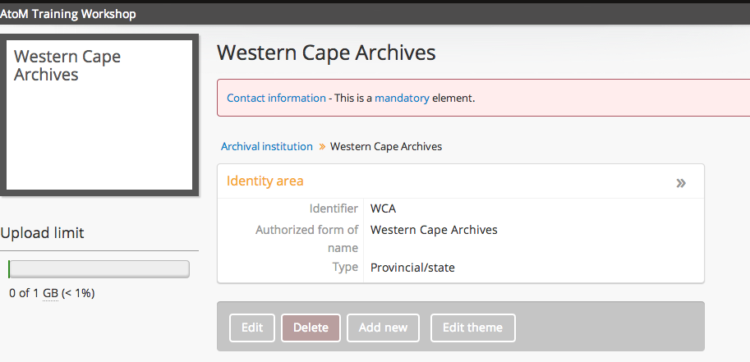
5.3 You will see that Contact information is a mandatory element in ISDIAH, click on the Edit button and select Contact area to add data.
- Add new
- Contact person enter: Jane Demers
- Telephone: 27 21 483 0400
- Email: Archives.Enquiries@westerncape.gov.za
- Click on the Physical location tab
- Street address: 72 Roeland Street
- Country start typing: South Af (and then select South Africa from the list)
- City: Cape Town
- Click on the Submit button and then the Save button.

5.4 Continue entering data into your archival institution record: Description area, Access area, Services area and Control area. There are two methods to re-enter the edit template.

- Click on the Edit button (as you have done previously in this tutorial)
or
- Click on the double arrows >> to access a section of the edit template directly.

See below for an example of what your Archival institution record could look like.

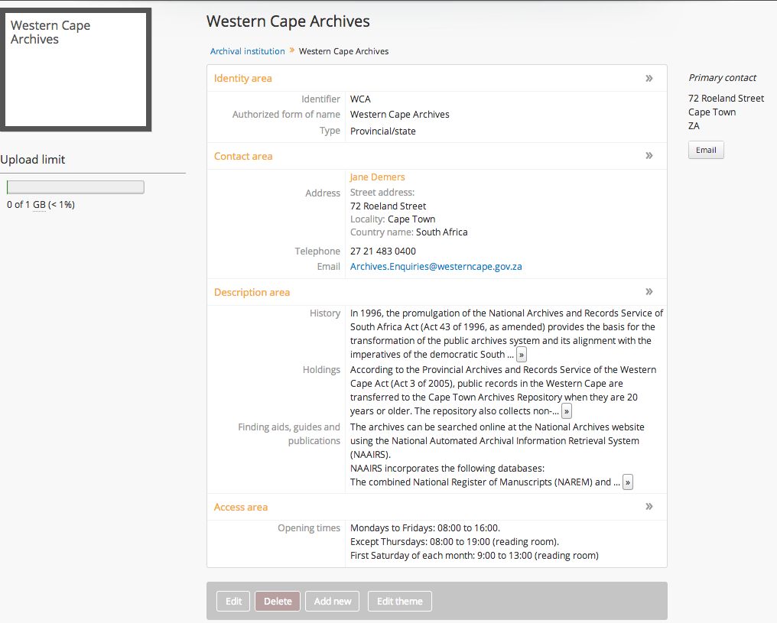
You will notice a the Edit theme button at the bottom of the page. This is a new feature in AtoM 2.0, it allows authenticated users to customize the “look” of the archival institution's record. This feature is useful in a consortial or portal situation, where there are more than one institution in a database.
5.5 Click on the Edit button.
- Background color click in empty box and select color.
- Click the Save button.

AtoM will reload the archival institution page with your selected background color. You can always change it by selecting the Edit theme button.

- Logo click on Choose File and select WCA.ZA.png file from desktop
- Page content enter: <strong>Western Cape Archives, better together</strong>
- Click on the Save button.

AtoM also provides the option of adding a banner as part of the customization. For now, you can see the changes you have made. We will continue to work within this archival institution throughout the following tutorials, so don't worry if you didn't choose light green as your color.
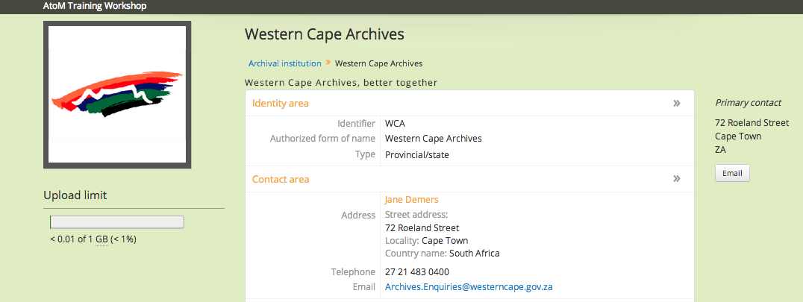
You will see in an Upload limit in the left-side of the screen under the archival institution logo. This refers to the available storage capacity for digital objects. As you can see, Western Cape Archives has 1 GB of available space. This indicator bar is only shown to authenticated users and is a great tool for knowing when you need to purchase more storage!

Navigate to the Browse tab in the header bar at the top of the screen and select Archival institutions from the list. You should see that the Western Cape Archives has been added to the list of archival institutions available in the AtoM database. If you click on the WCA logo thumbnail, AtoM will load the Western Cape Archives page.

Congratulations!
You have successfully created and edited an Archival institution record.

Tutorial 6 Add and Edit Authority Record
In this tutorial you will learn how to add and edit an Authority record using the ISAAR-CPF compliant template.

6.0 Add Menu – Select Authority record

6.1 Navigate to the Add menu and select Authority record from the list of options.

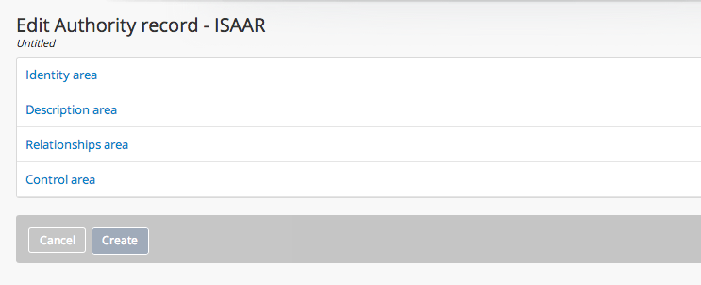
In the following exercise you will learn how to create an ISAAR compliant Authority record for a person, “Adam Bacher”. Each step is explained and all the required data is provided for you. Once you are comfortable with the process feel free to input any additional data in fields that are not included in this exercise. Note that the Tooltips will appear as you type, these are based on the ISAAR content standard.

6.2 Move through the edit template the same way you did in the previous tutorial. Open the Identity area to begin entering the data below:

- Type of entity select from the list: Person
- Authorized form of name enter: Adam Bacher
- Click the Create button

You should see an Authority record has been created for Adam Bacher. But there are warnings, you need to add more information to make the authority record compliant with ISAAR. Edit the record, either by clicking on the Edit button or clicking on the >> . Open the Description area to begin editing the record with information below:

- Dates of existence enter: 1973 -
- History enter: Born on 29 October 1973 in Johannesburg, Adam Bacher is a South African cricketer. He is a right-handed batsman and a right-arm medium-pace bowler.
- Internal structures/genealogy enter: He is the nephew of former South African captain and cricket chief Ali Bacher.
- General context enter: Bacher entered South African cricket in 1995/96 in the Under-24 side which toured Sri Lanka and made his Test debut against India at the back end of the following year. Bacher was picked once again in 2005 for an English One Day International, but he only played the first game of the one day series, and was dropped thereafter, following an extremely poor shot to a Mathew Hoggard delivery.
- Click the Save button.

Continue to add more information into the authority record. Go to the Control area and enter:

- Description identifier enter: AB-73
- Institution identifier enter: WCA
- Click the Save button.

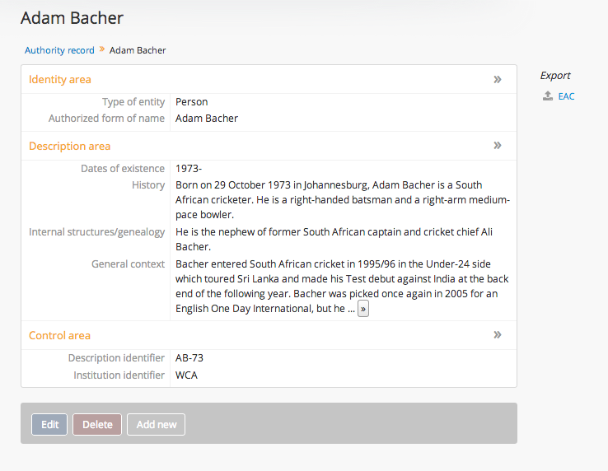
Congratulations!
You have successfully created and edited an Authority record.
Tutorial 7 Add and Edit Archival description
In this tutorial you will learn how to add and edit an Archival description using the ISAD(G) compliant template.

7.0 Add Menu – Select Archival description

7.1 Navigate to the Add menu and select Archival description from the list of options.
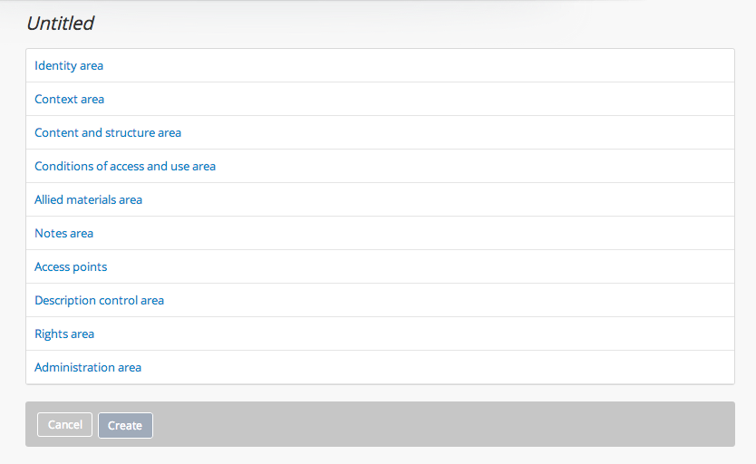
In the following exercise you will learn how to create a new archival description for a fonds entitled, “Cape Town Cricket Club”. Each step is explained and all the required data is provided for you. Once you are comfortable with the process feel free to input any additional data in fields that are not included in this exercise.

7.2 Move through the edit template the same way you did in the previous tutorial. Open the Identity area to begin entering the data below:
- Identifier enter: CTCC
- Title enter: Cape Town Cricket Club
- Dates enter into Date field: 1857 -
- Level of description select from the drop-down list: Fonds
- Add new child levels in Identifier enter: S01
- Add new child levels in Level select: Series
- Add new child levels in Title enter: Players
- Extent and medium enter: 14 meters of textual records (return) 30 photographic prints
- Click on the Save button

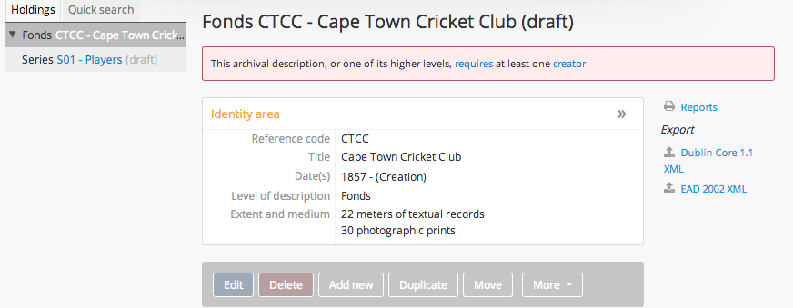

You are viewing the archival description for the Cape Town Cricket Club (fonds and series levels) that you created. Notice in the left-side of the screen there is a treeview that shows Fonds CTCC and nested beneath it the child level - Series Players.

Notice that the archival description is not compliant with ISAD(G) yet, it needs a creator. Go to the Edit button or click on the >> to begin editing the record. Open the Context area and enter the following data:

- Name of creator(s) enter: Cape Town Cricket Association (Note that AtoM suggests names from other authority records already entered into the database.)
- Repository place cursor in data entry field and Select Western Cape Archives from the list.
- Click on the Save button

View your archival description and notice that it is now associated with the Western Cape Archives, and the colors have changed, the logo is visible etc. You will also notice that the title of the record has (draft) next to it. The default of AtoM is that all new archival records have draft status, which means they cannot be viewed by the general public.
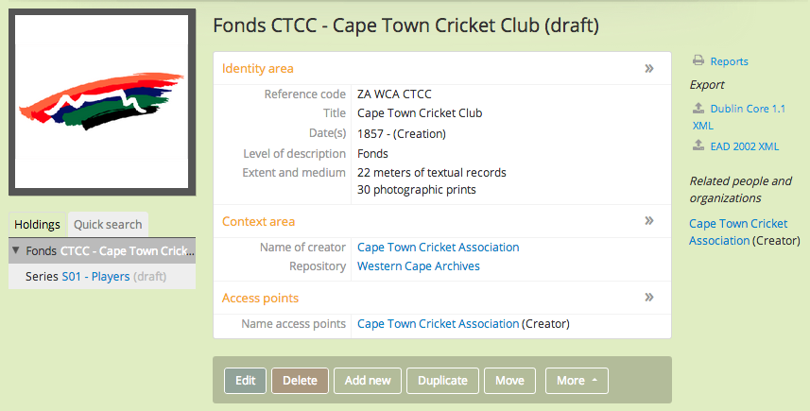
To change the publication status of an archival description, Click on the Edit button and enter the following data into the Administration area:

- Publication status select Published
- Click on the Save button

You will now see that the status of the Fonds (and its child level) is Published. This means that the archival description can be accessed and viewed by any public user of the database. This feature allows a lead archivist to approve archival descriptions that are created by assistants or volunteer archivists prior to publishing them to the public.

Take a few minutes to go Edit the record further, including the Access points area:
- Subject access points enter: Cricket
- Place access points enter: Cape Town

When you are finished remember to click on the Save button.

Navigate to the Browse menu in the header bar at the top of the page. Select Archival descriptions from the list of options. Because the list is sorted by recent updates, you should see the Cape Town Cricket Club as the first archival description on the list. Click on the title and AtoM will load the view archival description page.

Congratulations!
You have successfully created and edited an Archival description record.
Tutorial 8 Add Accession and Deaccession record
In this tutorial you will learn how to add a deaccesion record and add an accession record. There is no ICA standard for deaccession and accession records, so the template in AtoM has been created using best practices, which may or may not reflect the workflow and information that your organization uses. In the following exercise you will learn how to deaccession part of an accession and how to create an accession record, add a donor record and link the accession record with an archival description.

8.1 Accessions are only available to logged-in users, they are not made availble to public users. To browse an accession record you must navigate to the Manage menu in the header bar and click on Accessions from the options. AtoM loads the Browse accession page and there is one accession in the database. The browse page is organized with the name of the accession in once column and the date in the other column. The accessions can be sorted by most recent or alphabetic, and an accession search bar is provided.

In a multi-repository context, accessions are not used because they can be accessed and viewed by ANY logged-in user working for any archival institution.

- Click on: 2013-10-14/1
- View accession record page

8.2 As you review the information in the accession record note the hyperlinks to a related donor: Rachel Wright, the Creator: Colette Whiten, and an archival description: Colette Whiten fonds. The accession record can be a powerful first step in the processing workflow.

- Click on: Rachel Wright
- AtoM loads the View donor page (similar to a rights holder record and managed from the Manage menu the same way that rights holders are managed)
- Click on Related accession: 2013-10-14/1
- AtoM reloads the accession view page, Click on: Colette Whiten fonds
- AtoM loads the view archival description page for that related fonds. Scroll down and note that this archival description has an Accession area at the end with a hyperlink to the related accession. Click to return to the accession record.

8.3 In the View accession record page, the button block at the bottom of the page reveals a number of potential actions: Edit, Delete, Deaccession, Add accrual, and Create Archival description.

- Click the deaccession button
- AtoM loads the Edit deaccession record page.
- Deaccession number enter: 01
- Scope select: Part
- Description enter: Two graphite drawings of a boat and nautical tools.
- Extent enter: 2 graphite drawings on rag paper; 11” x 17”
- Reason enter: Sketches #12-14 were mistakenly attributed to Colette Whiten, but were created by her assistant, Jackie Gold. The sketches are being deaccessioned, removed and returned to Jackie Gold's estate.
- Click on Create button
- AtoM loads the View accession record page and at the bottom is a deaccession area with a hyperlink to the record: 2013-10-14/1-D01

8.4 In this exercise you will create an accession record, a donor record and generate an archival description from the accession record. (If you are taking a long time to enter the information make sure you save often.)

- Navigate to the Add menu and select accession record from the options
- AtoM loads the Edit accession record page, in the Basic info area:
- Immediate source of acquisition enter: Fonds acquired from Women's College Hospital Auxiliary on October 21, 2013.
- Location information enter: Archives storage, aisle 3, shelf C.

- In the Donor/transferring body area:
- Name enter: Women's Auxiliary
- Contact person enter: Janet Ritter
- Street address enter: 77 Lake Road
- Region/province enter: Ontario
- Country select: Canada
- Telephone enter: 1-888-345-0982
- Click on the Submit button

- In the Administrative type area:
- Acquisition type select: transfer
- Resource type select: Private transfer
- Title enter: Women's College Hospital Auxiliary meeting minutes
- Creators enter: Women's College Hospital Auxiliary
- Scope and Content enter: 12 books containing meeting minutes from the Annual General Meeting of the Women's College Hospital Auxiliary
- Click on the Save button

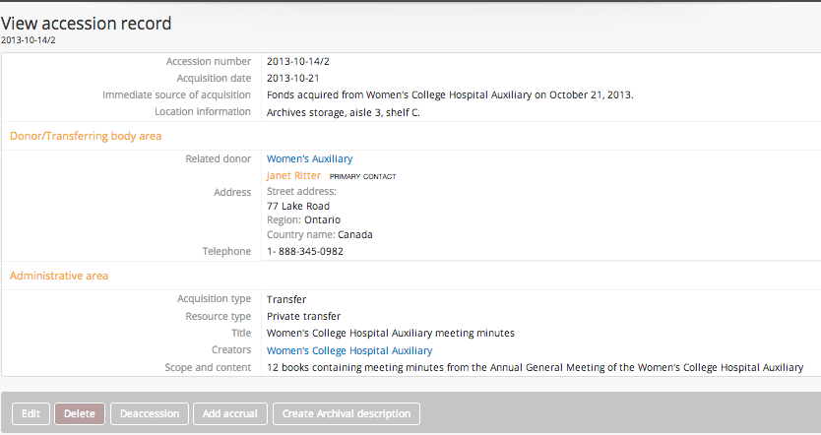
AtoM loads the View accession record page

You have created an accession record for an acquisition of meeting minute books created by the Women's College Hospital Auxiliary. You also created a donor record for the Women's Auxiliary. Note that the button block provides the option to Add an accrual or Create an archival description.

8.5 In this exercise you will create an archival description from your accession. This is a different workflow from creating a new archival description using the Add menu (as you did earlier in the workshop).
- Click on the Create Archival description button

AtoM loads the view archival description page for the Women's College Hospital Auxiliary meeting minutes (draft), BUT the difference is that the information you entered into the accession record has pre-populated the archival description record.

- Click on the Edit button and add any information you would like to the archival description and then click on the Save button.

You have created an archival description record for the Women's College Hospital Auxiliary meeting minutes and it is linked to the related accession record and donor record.

This exercise shows you that AtoM can be used to support the following workflow: (1) Create accession record for newly acquired materals; (2) Produce a donor record; (3) Produce an authority record; (4) Generate an archival description; and if necessary (5) deaccession part (or all of) an archival collection.

Tutorial 9 Import, Edit and link Digital objects
In this tutorial you will learn how to Import multiple digital objects, Edit and Link a single digital object.The digital objects can be audio files, video files, image files and pdfs. The digital objects can be located at a URL, on a remote server, or your desktop.

9.0 Import, Edit & Link Digital Objects to Cape Town Cricket Club

9.1 Navigate to the Cape Town Cricket Club fonds.
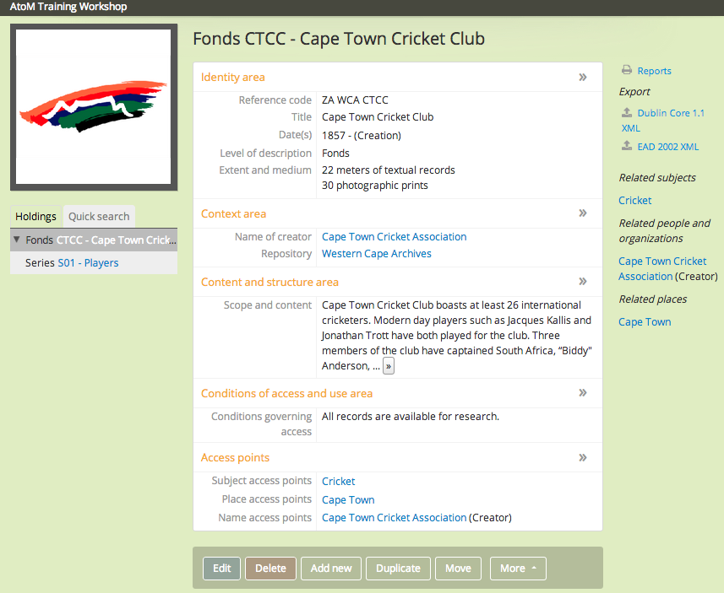
In the following exercise you will learn how to import multiple digital objects and edit and link single digital objects to the “Cape Town Cricket Club”. Each step is explained and all the required data is provided for you. Once you are comfortable with the process feel free to input any additional data in fields that are not included in this exercise.
9.2 In the treeview, click on the series level title “Players”. AtoM will reload the page and present the minimal archival description for the Players series (a child-level of the CTCC fonds). You will see a warning that asks for information to be added to the Date(s) field and to the Extent and medium field.
- Click on the Edit button
- In the Identity area, go to Date(s), in Date enter: 1900-
- Extent and medium enter: 5 color photographs
- Click on the Save button

You have created the record for the series-level description of Players. Now you will import digital photographs of different players. At the bottom of the Series-level record click on the More button, and select Import digital objects:
- Level of description select from the drop-down list: Item-level
- Click on the Select files button.

AtoM opens a browse window that will open a finder to the files on the computer you are working with. Find the folder entitled Players and select all the JPG files inside it and select the Open button.

AtoM will load all the JPG files, at this time you can rename the files using the names of the players. For example, LonwaboTsotsobe.jpg file should be named Lonwabo Tsotsobe. When completed, click on the Import button and import ALL the digital image files.
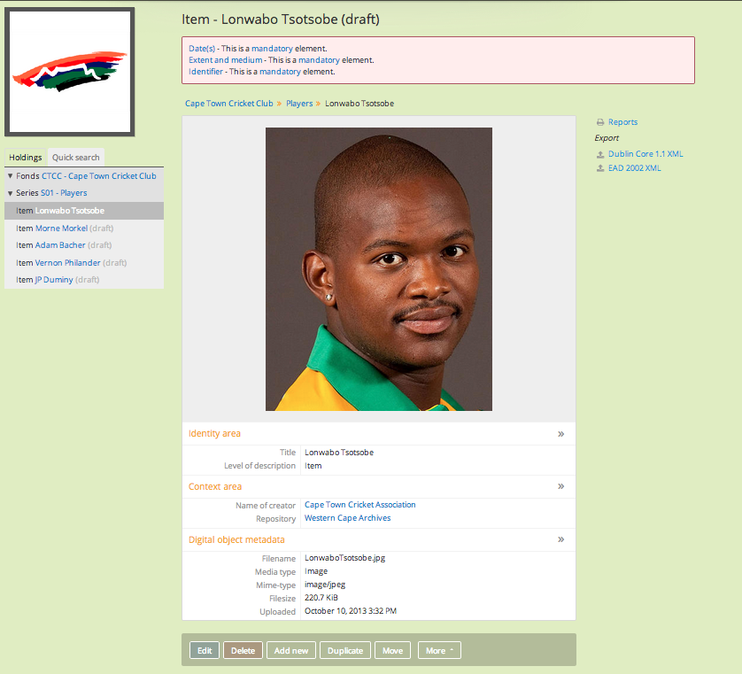

On the left-side of the screen in the treeview, you can see that the Series titled Players, has 5 item-level descriptions listed below. Those items are the individual photographs of each player that you have imported into the fonds/collection. If you click on each Item title, you will see the individual records and the imported photographs, in draft status. If you click on the fonds-level title, CTCC you will see the cover flow viewer with all the images in the lower-levels.

You will know what level you are looking at because the title contains the term “Fonds” or “Series” or “Item”. Additionally, the treeview will provide a darker bar to let you know what level you are looking at, in the example below it is the Fonds level.
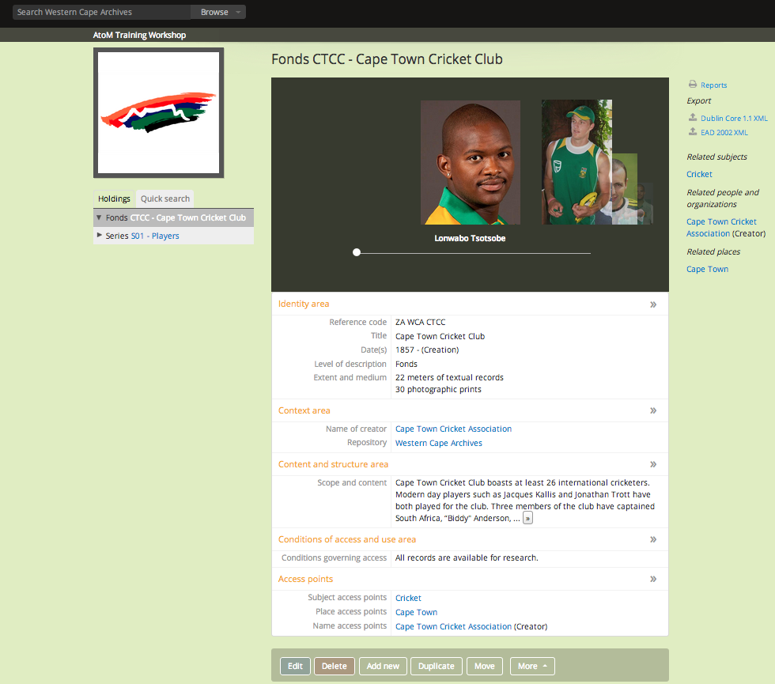
You can also see that any searches conducted in the search bar will default to holdings in the Western Cape Archives. On the right-side of the screen any related places are listed (e.g., Cape Town) and related subjects (e.g., Cricket) as well as related authority records (e.g., creator record – Cape Town Cricket Association. All of those relationships are hyperlinks.
9.3 The next exercise will teach you how to edit an existing digital object. First, navigate to the item-level description for Adam Bacher. Click on the More button and select Edit digital object from the options.

AtoM loads the Edit digital object page and you can review the Master (accessible to authorized users), the Reference representation (made available to public users for download) and the Thumbnail representation (used in the AtoM interface as a placeholder). Because we used a small file for our Master image of Adam Bacher, there isn't a big difference between the representations, but you could have a 50 mb TIFF as the Original and a 500 kb JPG as the Reference.

Navigate to the bottom of the page and Click on the Delete button. You will be asked if you are sure that you want to delete the digital object, Click on the Delete button. It is important to understand you are deleting the digital object NOT the archival description it is attached to.
AtoM will reload the Adam Bacher item-level description, as you can see, it no-longer has a digital image linked to it.

Navigate to the bottom of the page and Click on the More button and select Link digital object. AtoM will load the single digital object page. Do not upload a digital object, go to the Link to an external digital object and enter this URL: http://www.sporting-heroes.net/content/thumbnails/00011/00971-zoom.jpg. Click on the Create button.

AtoM reloads the item-level description for Adam Bacher with the new image. In the digital object metadata section of the archival description the URL for the linked image is available.
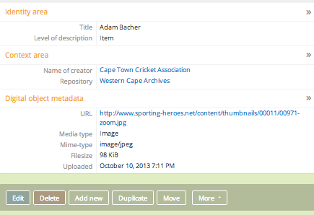

There is a folder with a pdf file, a movie file, and an audio file in the folder titled MEDIA on your desktop, feel free to play around with attaching different types of media to any archival description in the database. Remember that you must specify the level of description when uploading multiple digital objects, whereas, linking or uploading a single digital object will automatically link it to the level of the archival description you are viewing.
Congratulations!
You have successfully imported, edited and linked a digital object.

Tutorial 10 Add Terms
In this tutorial you will learn how to create a hierarchical subject taxonomy.

10.0 Go to Homepage – Add Term

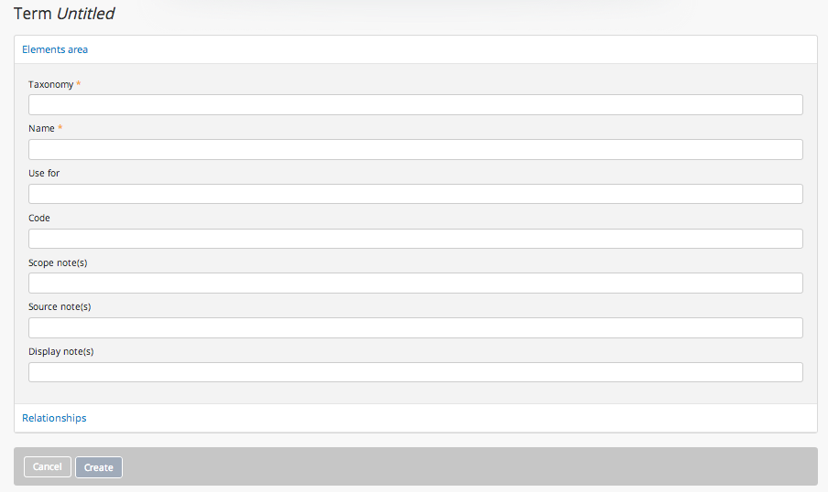
10.1 Navigate to the the Homepage and Click on the Add menu and select Term from the list of options. AtoM loads the Term page. Earlier, you added Place and Subject access points using the archival description edit template (e.g., Cape Town and Cricket). In this exercise you are going to create a Term with Relationships, which provides more control and builds a taxonomy of hierarchical terms.

10.2 Enter the following data into the Elements area:
- Taxonomy enter: Sub (type slowly, AtoM will provide auto-complete) select Subjects
- Name enter: Sports
- Use for enter: physical activity (hit tab) games (hit tab) sporting events (hit tab)

Enter the following data into the Relationships area:
- Broad term enter: Spo (type slowly, select from the list: Sports, recreation and leisure)
- Add new narrow terms enter: Lacrosse (tab) Hockey (tab)
- Click on the Create button.
You will want to add Cricket (which you created earlier) as a narrow term under Sports so the relationship can be made between the terms. Navigate to the Browse tab and select subjects from the options. Find Cricket in the list and click on it. AtoM loads a Browse Subjects Cricket page, in the top-right hand corner click on the Manage term button. View the cricket page and click on the Edit button and enter the following data in the Relationships area:

- Broad term enter: Spo (type slowly, select from the list: Sports)
- Click on the Save button.
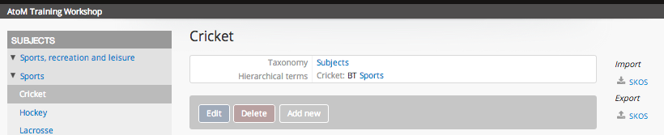
On the left-side of the screen is the treeview showing the hierarchy of the taxonomy, with cricket highlighted in grey. Click on Sports and AtoM loads the term page for Sports, showing the taxonomy of Narrow terms and Use for terms.
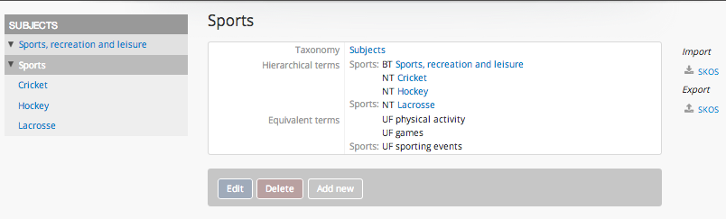
If another archivist tries to enter “physical activity” as a subject term – AtoM will prompt them to use: Sports. This allows the archivist to create some control over subject access points being added into the database during archival description.

Now if you view your subject access point “cricket” in the Cape Town Cricket Club fonds you can see that it has a breadcrumb trail that provides greater context. This is useful for place access points.
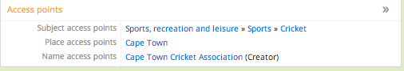
Tutorial 11 Link Physical Storage
In this tutorial you will learn how to Link Physical Storage to an archival description.

11.0 Link physical storage to Cape Town Cricket Club

11.1 Navigate to the the Cape Town Cricket Club fonds. You can locate it in the Browse list of Archival descriptions, or type “Cricket Club” into the search bar and select it from there.

11.2 On the bottom of the Fonds CTCC-Cape Town Cricket Club page is the list of buttons. Click on the More button and select Link physical storage.

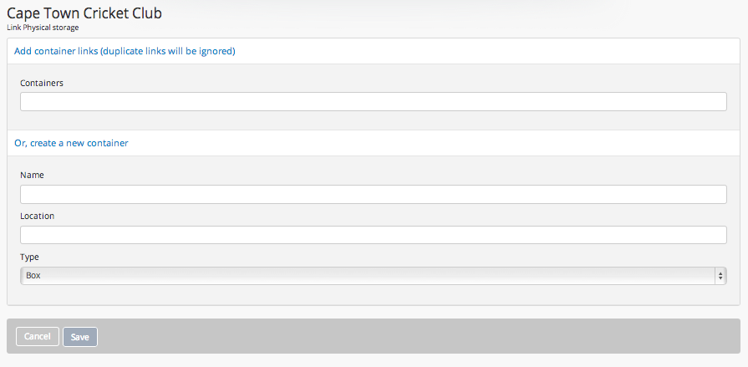
You have the choice of selecting an existing container or creating a new container. For this exercise you will create a new container:
- Name enter: CTCC-01
- Location enter: Row 6, Shelf C
- Type select: Hollinger Box
- Click on the Save button.

In the View archival description page for Cape Town Cricket Club, you will now see on the right-side of the screen under the heading Physical storage the location information you just created.
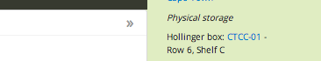

The Title of the container is a hyperlink and if you Click on it, AtoM will take you to the View physical storage page, where you can edit, delete and print the container. If you need to delete a storage container, from the view physical storage page all you need to do is click on the red Delete button. If a Physical storage container is associated with a number of collections, you need to be careful, as deleting it will cause cascading deletes.

Congratulations!

You completed all 10 Tutorials in the AtoM 2.0 – Authenticated Users Training Workshop.

AtoM 2.0 is a very powerful application, there are many more features that we could not cover in a one day workshop. The user manual is online and can be accessed at any time of day. Additionally, any question can be posted to the ICA-AtoM User forum, which is a community google group of users from around the world that help troubleshoot problems and offer useful tips on how to effectively work with the software in a variety of archives, special collections, libraries and museums.

https://www.accesstomemory.org/en/

https://groups.google.com/forum/#!forum/ica-atom-users

