25


Archeion for Archivists

Contents
Contents 2
How Archeion works 2
Notes 2
1.Description of your archival institution 3
Identity area (ISDIAH 5.1) 3
Contact area (ISDIAH 5.2) [Required] 4
Description area (ISDIAH 5.3) 4
Access area (ISDIAH 5.4) 5
Services area (ISDIAH 5.5) 5
Control area (ISDIAH 5.5) 6
2.Creators of archives 7
Identity area (ISAAR-CPF 5.1) 7
Description area (ISAAR-CPF 5.2) 8
Relationships area (ISAAR-CPF 5.3) 11
Control area (ISAAR-CPF 5.4) 13
3.Description of archival fonds and collections 14
Title and statement of responsibility area (RAD 1.1B) 14
Edition area (RAD 1.2) 15
Class of material specific details area (RAD 1.3) 15
Dates of creation area (RAD 1.4) 15
Physical description area (RAD 1.5B) [Required] 16
Publisher's series area (RAD 1.6) 17
Archival description area (RAD 1.7) 17
Notes area (RAD 1.8) 17
Standard Number area (RAD 1.9) 19
Access points (RAD 21) [Required] 20
Control area 23
Rights area (PREMIS <rights>) 23
Administration area 23
4.Adding sous-fonds, series, files or items 24
5.Adding digital objects (images, audio or video) 25
Archeion (www.archeion.ca) is Ontario's online gateway to archives and is provided by the Archives Association of Ontario (AAO). Institutional members of the AAO can provide information about their institution, their archives and the creators of those archives to Archeion so that they are available on the web for people to discover. Descriptions in Archeion are also supplied to the national ArchivesCanada service, where they can be searched alongside records from Canada's other provinces and territories.

How Archeion works
Archeion holds three different types of records, all based on national or international standards.
- Details of archival institutions (based on the ISDIAH standard)
- Information about creators of archives (based on the ISAAR-CPF standard)
- Descriptions of the archives themselves (based on RAD)
In order to share information about your archives, you will need to create each of these types of records. The following sections explain how to do this in more detail.

Notes
Some information fields in these records are required by the software system. There are additional fields which are considered by the AAO to be mandatory for Archeion. In this manual these fields are all marked [Required].
For additional help on contributing records to Archeion, please contact the Archeion Coordinator by email at archeion@aao-archivists.ca.

Description of your archival institution
This is the first record you should create or check. It holds details of your archive's opening hours, contact details, access policy and any additional information about the institution which you would like to share with the public. This page will be linked from every one of your archival descriptions, so it is important that the information in it is correct so that users will know how to get in touch with you.
To view and edit an existing institutional record:
- Log in to Archeion with your email address and password
- Follow the 'Archival institutions' link from the Browse menu on the left of the Archeion home page
- You can page through the results to find your institution or you can use the 'Search Archival institution' box at the bottom of the page
- Click on your institution's name when you get to it to view the details
- If you need to change anything, click on the 'Edit' button at the bottom of the screen to open the record for editing
To create a new institutional record, click on the 'Add' menu at the top left of the screen, then click 'Archival institution'.
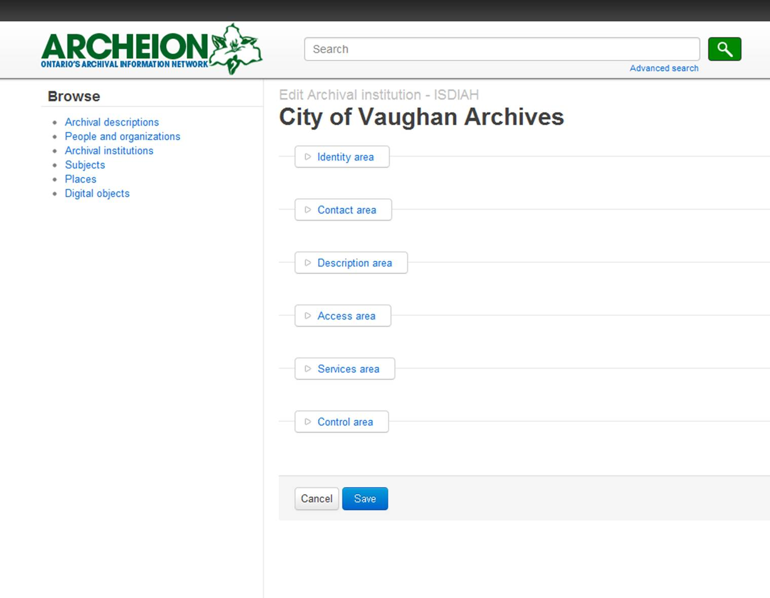
Institutional records can contain quite detailed information about an archive's services. When you first open a record for editing you will see the headings of the different sections. Click on the name of the sections to bring up the fields you can edit.

Identity area (ISDIAH 5.1)
This section identifies your repository by name and by its Archeion number.
This is how it looks:
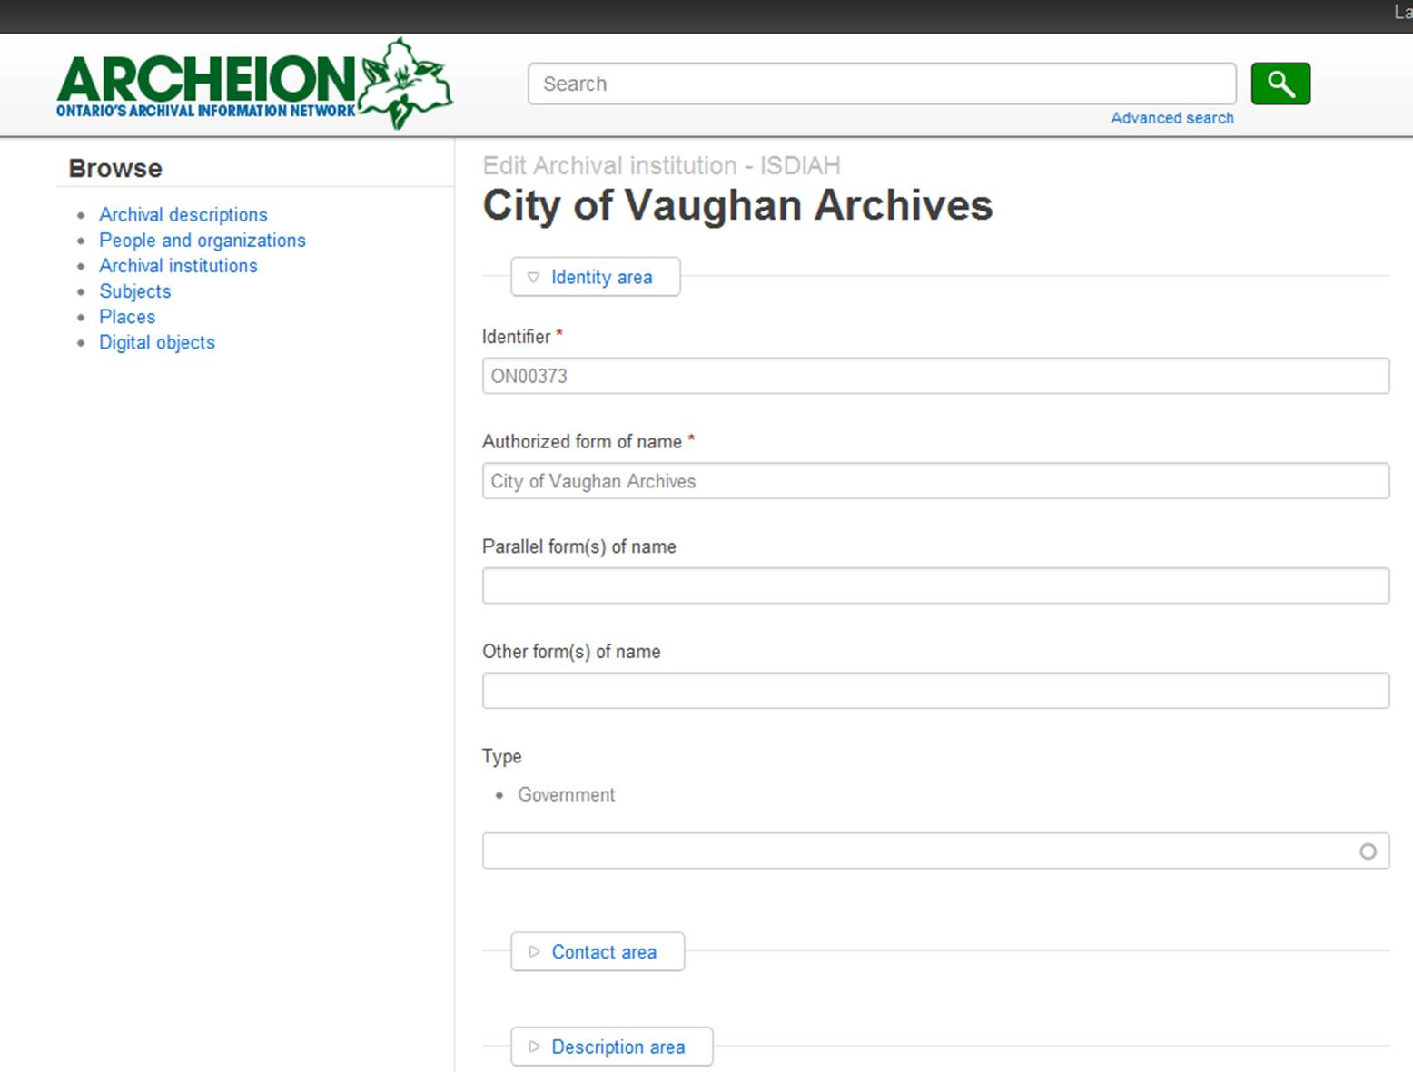

Identifier (ISDIAH 5.1.1) [Required]
Record the alpha-numeric Archeion code for your institution. This is composed of the letters ON followed by a five-digit number. Contact the Archeion Coordinator if you do not know your institution's code.

Authorized form(s) of name (ISDIAH 5.1.2) [Required]
Put the official name of your repository in this field.

Parallel form(s) of name (ISDIAH 5.1.3)
If your repository has an official name in French and in English, use one of these as the Authorized form of name and put the other here.

Other form(s) of name (ISDIAH 5.1.4)
Record any other name(s) by which the institution may be known. This could include other forms of the same name, acronyms; other institutional names; or changes of name over time, including, if possible, relevant dates.

Type (ISDIAH 5.1.5)
The Type field is chosen from a list of different repository types. Choose the one that is most appropriate to your repository.

Contact area (ISDIAH 5.2) [Required]
This section is for your institution's physical address, email, telephone, fax and website details. A street address is required. Click on the pencil icon at the right to edit existing details or click 'Add new' if you need to supply additional information. Enter the details you want to record in the pop-up form which appears and, when the details are complete, click 'Submit' to return to the main form. If you have several contacts listed, you can use the 'Primary contact' check box in the pop-up menu to indicate the main one. Be sure to click 'Save' on the main form to save your details.
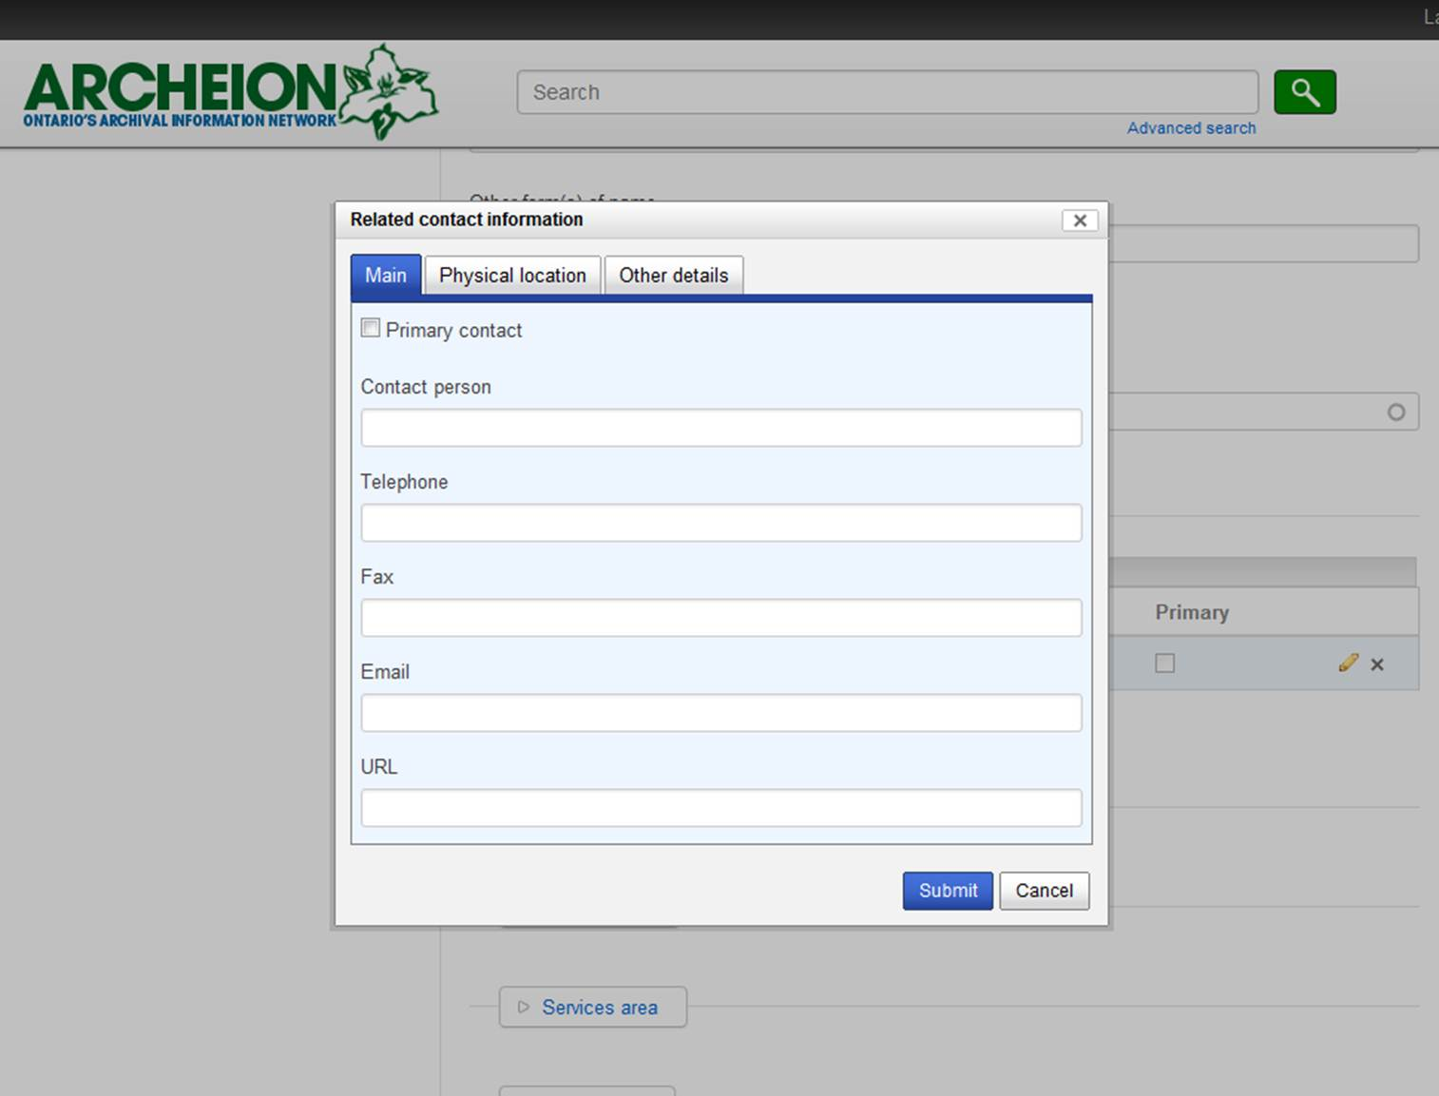

Description area (ISDIAH 5.3)
The fields in this section allow you to provide further information about your institution. They are all optional.

History [of the institution] (ISDIAH 5.3.1)
Record any relevant information about the history of the institution. This element may include information on dates of establishment, changes of names, changes of legislative mandates, or of any other sources of authority for the institution.

Geographical and cultural context (ISDIAH 5.3.2)
Complete this field to provide information about the geographical and cultural context of the institution.

Mandates/Sources of authority (ISDIAH 5.3.3)
Record any document, law, directive or charter which acts as a source of authority for the powers, functions and responsibilities of the institution, together with information on the jurisdiction(s) and covering dates when the mandate(s) applied or were changed.

Administrative structure (ISDIAH 5.3.4)
Describe, in narrative form or using organisational charts, the current administrative structure of the institution.

Records management and collecting policies (ISDIAH 5.3.5)
Record information about the records management and collecting policies of the institution. Define the scope and nature of material which the institution accessions. Indicate whether the repository seeks to acquire archival materials by transfer, gift, purchase and/or loan. If the policy includes active survey and/or rescue work, this might be spelt out.

Buildings (ISDIAH 5.3.6)
Record information on the building(s) of the institution (general and architectural characteristics of the building, capacity of storage areas, etc.).

Archival and other holdings (ISDIAH 5.3.7)
Record a short description of the holdings of the institution, describing how and when they were formed. Provide information on volume of holdings, media formats, thematic coverage, etc.

Finding aids, guides and publications (ISDIAH 5.3.8)
Record the title and other pertinent details of the published and/or unpublished finding aids and guides prepared by the institution with archival holdings and of any other relevant publications.

Access area (ISDIAH 5.4)
The fields in this section are optional but important for users and therefore recommended for institutions represented in Archeion.

Opening times (ISDIAH 5.4.1)
Record the opening hours of the institution and annual, seasonal and public holidays, and any other planned closures. Describe times associated with the availability and/or delivery of services (for example, exhibition spaces, reference services, etc.). These can be updated at any time, which may be useful for unexpected closures.

Conditions and requirements (ISDIAH 5.4.2)
Describe access policies, including any restrictions and/or regulations for the use of materials and facilities. Record information about registration, appointments, letters of introduction, admission fees, etc. Where appropriate, make reference to the relevant legislation.

Accessibility (ISDIAH 5.4.3)
Record information about travelling to the institution and details for users with disabilities, including building features, specialized equipment or tools, parking or elevators.

Services area (ISDIAH 5.5)
The fields in this section are optional but important for users and therefore recommended for institutions represented in Archeion.

Research services (ISDIAH 5.5.1)
Record information about the onsite services provided by the institution such as languages spoken by staff, research and consultation rooms, enquiry services, internal libraries, map, microfiches, audio-visual, computer rooms, etc. Record as well any relevant information about research services, such as research undertaken by the institution, and the fee charged if applicable.

Reproduction services (ISDIAH 5.5.2)
Record information about reproduction services available to the public (microfilms, photocopies, photographs, digitized copies). Specify general conditions and restrictions to the services including applicable fees and publication rules.

Public areas (ISDIAH 5.5.3)
Record information about spaces available for public use (permanent or temporary exhibitions, free or charged internet connection, cash machines, cafeterias, restaurants, shops, etc.).

Control area (ISDIAH 5.5)
These fields are optional, but the Institutional identifier should be completed. It takes the form CA ON00* (e.g. CA ON00373 in the case of the City of Vaughan Archives).
Once you are happy with your institutional record, you can save it and go on to create archival descriptions which will be automatically linked to your institution's details.

Creators of archives
In Archeion, information about creators of archives is held separately from the description(s) of the fonds or collection with which they are associated. These 'authority records' are compiled before the description of the fonds or collection itself, so that they are easily linked into the archival description when it is created.
Authority records are created and edited in a similar way to the institutional descriptions in part 1 of this guide:
- Log in to Archeion with your email address and password
- Follow the 'People and organizations' link from the Browse menu on the left of the Archeion home page
- Browse or search these records to see whether the person, family, or organization you are wanting to describe already exists in the system
- If not, click 'Add' at the top left of the screen
- Click 'Authority record' to make a new record for your creator
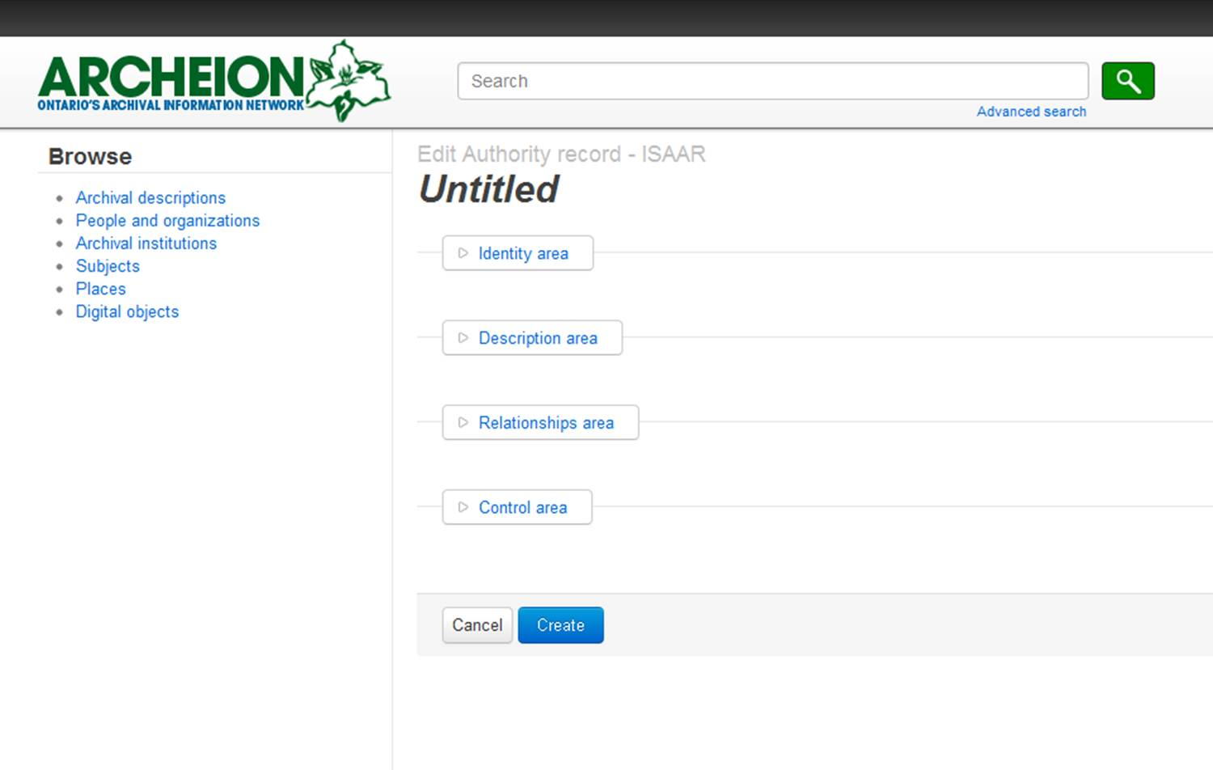
When you first create an authority record (or open one for editing) you will see the headings of the different sections. Click on the name of the sections to bring up the fields you can edit.
When you have completed the form, click on the 'Create' button at the bottom of the window to save your new authority record. It will immediately be made available on Archeion, even if you save it as a draft record.

Identity area (ISAAR-CPF 5.1)
Fields marked with an asterisk are required. In this section, the required fields are the Type of entity (Person, Family or Corporate body) and the Authorized form of name.

Type of entity (ISAAR-CPF 5.1.1) [Required]
Choose the type of entity (Corporate body, Family or Person) that is being described in this authority record from the drop-down list.

Authorized form(s) of name (ISAAR-CPF 5.1.2) [Required]
Record the standardized form of name for the entity being described in accordance with the Rules for Archival Description, but do not put dates in this field (use the separate Dates of existence field in the Description area for this).
Examples:
Peerless Machine and Tool Company
Université d'Ottawa. Faculté des arts
Ariss, Alison
Smith, J. Allan (James Allan)
Watson, Sheila
Emmanuel College (Toronto, Ont.). Faculty
Godard, Barbara
Atkins (family)
Arts and Letters Club of Burlington
Adjala-Tosorontio (Ont. : Township)

Parallel forms of name (ISAAR-CPF 5.1.3)
Record the parallel form(s) of name of an organization, for example the French or English name of an official body.

Standardized forms of name according to other rules (ISAAR-CPF 5.1.4)
Record the standardized form of name for the entity being described in accordance with other conventions or rules. Specify the rules and/or if appropriate the name of the agency by which these standardized forms of name have been constructed.

Other forms of name (ISAAR-CPF 5.1.5)
Record other names by which the entity may be known, such as:
- a) other forms of the same name, e.g. acronyms;
- b) other names of corporate bodies, for example, changes of name over time and their dates;
- c) pseudonyms, maiden names, etc.;
- d) names and prenominal and postnominal titles of persons and families, e.g. titles of nobility, or titles of honour held by the individual or family.

Identifiers for corporate bodies (ISAAR-CPF 5.1.6)
Record where possible any official number or other identifier (e.g. a company registration number) for the corporate body and reference the jurisdiction and scheme under which it has been allocated.

Description area (ISAAR-CPF 5.2)
The purpose of this area is to describe the history, roles, context and activities of the corporate body, person or family. In this section, the only required field is Dates of existence.

Dates of existence (ISAAR-CPF 5.2.1) [Required]
Record the dates of existence of the entity being described. For corporate bodies include the date of establishment/foundation/enabling legislation and dissolution. For persons include the dates or approximate dates of birth and death or, when these dates are not known, floruit dates (i.e. dates when the person was known to be active).
Examples:
1924- | Living person
1900 Jan. 10- | To distinguish between two individuals with the same name born in the same year
1837-1896 | Both birth and death years known
1836 or 1837-1896 | Year of birth uncertain; known to be one of two years
1837?-1896 | Probable year of birth
ca. 1837-1896 | Year of birth uncertain by several years
1837-ca. 1896 | Approximate year of death
ca. 1837-ca. 1896 | Both years approximate
b. 1825 | Year of death unknown
d. 1859 | Year of birth unknown
fl. 1893-1940 | Years of birth and death unknown. Some years of activity known.
12th cent. | Years of birth and death unknown, years of activity unknown, century known.
13th/14th cent. | Years of birth and death unknown. Years of activity unknown, but active in both centuries.

History (ISAAR-CPF 5.2.2)
Record in narrative form or as a chronology the main life events, activities, achievements and/or roles of the entity being described. This may include information on gender, nationality, family and religious or political affiliations. Wherever possible, supply dates as an integral component of the narrative description. Give an overview of the person/organization/family in the first sentence.
For a corporate body, include information on:
- Dates of founding and/or dissolution
- Mandate/sphere of responsibility
- Predecessor and successor bodies
- Administrative relationships with other bodies
- Administrative structure
- Names of the chief officers
- Other significant information
For individuals, include details of:
- Place and dates of birth and death
- Place(s) of residence
- Occupation, education and activities
- Names of family members

Places (ISAAR-CPF 5.2.3)
Record the name of the predominant place(s)/jurisdiction(s), together with the nature and covering dates of the relationship with the entity.

Legal status (ISAAR-CPF 5.2.4)
Record the legal status and where appropriate the type of corporate body together with the covering dates when this status applied.

Functions, occupations and activities (ISAAR-CPF 5.2.5)
Record the functions, occupations and activities performed by the entity being described, together with the covering dates when useful. If necessary, describe the nature of the function, occupation or activity.

Mandates/Sources of authority (ISAAR-CPF 5.2.6)
Record any document, law, directive or charter which acts as a source of authority for the powers, functions and responsibilities of the entity being described, together with information on the jurisdiction(s) and covering dates when the mandate(s) applied or were changed.

Internal structures / Genealogy (ISAAR-CPF 5.2.7)
Describe the internal structure of a corporate body and the dates of any changes to that structure that are significant to the understanding of the way that corporate body conducted its affairs (e.g. by means of dated organization charts).
Describe the genealogy of a family (e.g. by means of a family tree) in a way that demonstrates the inter-relationships of its members with covering dates.

General context (ISAAR-CPF 5.2.8)
Provide any significant information on the social, cultural, economic, political and/or historical context in which the entity being described operated.

Relationships area (ISAAR-CPF 5.3)
The purpose of this area is to describe relationships with other corporate bodies, persons and families as may be described in other authority records. It also serves as a link between an authority record and any related archival descriptions.

Links between authority records
To establish a link between the authority record you are editing and an existing authority record, you must click 'Add new' under the Related corporate bodies, persons or families section of this area. A pop-up window appears, looking like this:
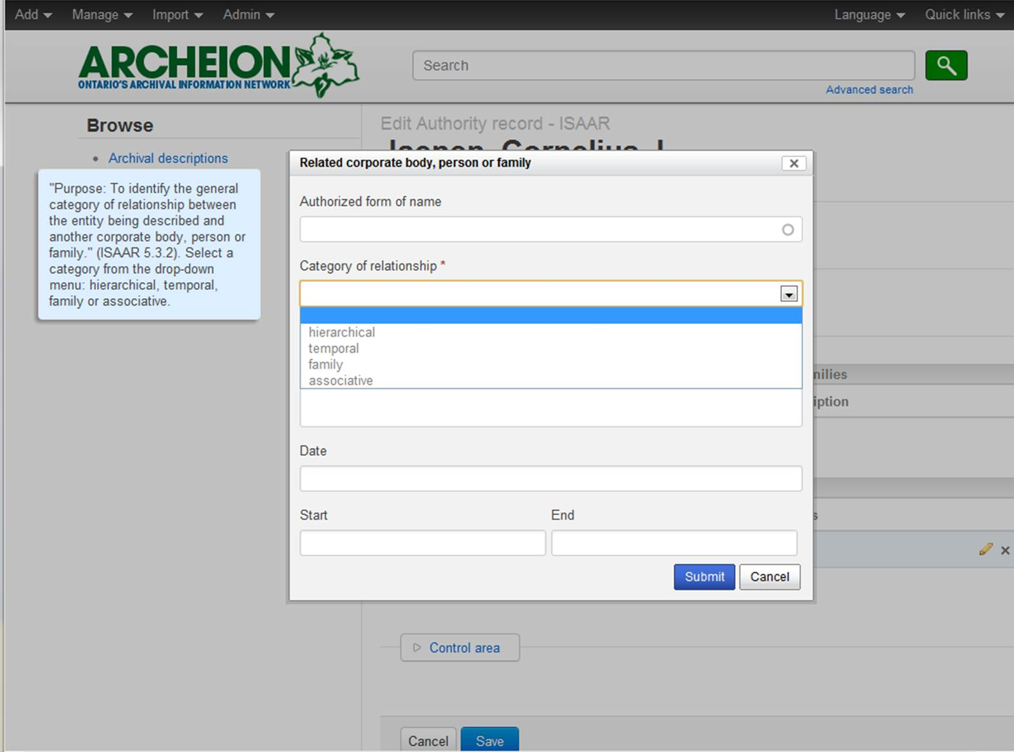
To insert the name of an existing authority, start typing in the Authorized form of name field and select the name when it appears. Be sure to click on the name in the list, otherwise you will create a new authority file with the same name!

Category of relationship (ISAAR-CPF 5.3.2)
ISAAR supports four types of relationship. Choose one of the following from the drop-down list:
Hierarchical (e.g. superior/subordinate; controlled/controlling; owner of/owned by)
In a hierarchical relationship an entity may exercise some authority and control over the activities of a number of other corporate bodies, persons or families. An entity may also be subordinate to a number of other corporate bodies, persons or families, as for example a joint-committee or an organization whose governing body changed over time.
Temporal (e.g. predecessor/successor)
In a temporal relationship an entity may succeed a number of other corporate bodies, persons or families in exercising some functions and activities. In turn it may be succeeded by a number of other corporate bodies, persons or families.
Family
In a family a person may have a wide circle of relationships with other members of the family and with the family as an entity. Where the genealogical structure of the family is complex it may be appropriate to create separate authority records for each member and link them to parent(s), spouse(s) and child(ren). Alternatively this information may be recorded in the Internal structure(s)/Genealogy element (5.2.7).
Associative
An associative relationship is a general category for relationships not covered by any of the above (e.g. Provider/client, membership, part/whole, business partner).

Description of relationship (ISAAR-CPF 5.3.3)
Record a precise description of the nature of the relationship between the entity described in this authority record and the other related entity.

Dates of the relationship (ISAAR-CPF 5.3.4)
Record where relevant the start and end dates of the relationship between the two entities.
Note that a link between two authority records can be made in either record. Once established, the link will automatically appear in the other record.

Links with archival descriptions
To establish a link with an existing archival description, click the 'Add new' link under the Related resources section of this area. Start typing the title of the archival description in the Title of related resource field and click on it when it appears.
In the context of Archeion, it is assumed that the Type of the related resource (ISAAR-CPF 6.2) will be 'Archival material'.

Nature of the relationship (ISAAR-CPF 6.3)
Describe the nature of the relationships between the corporate body, person or family and the related resource using a selection from the drop-down list of events. The options supported are:
Accumulation
Broadcasting
Collection
Contribution
Creation
Custody
Distribution
Manufacturing
Publication
Reproduction

The default option is 'Creation'.

Date of the related resources and/or relationship (ISAAR-CPF 6.4)
Provide start and end dates for the related resource or the dates of the relationship of the authority record entity with that resource.

Note that a link between an authority record and an archival description can be made in either the authority record or the archival description. Once established, the link will automatically appear in the other record.

Control area (ISAAR-CPF 5.4)
The control area relates to the creation and maintenance of the authority record. None of these fields are currently essential for Archeion descriptions, but they may prove useful for your repository for administrative purposes, for example for recording information on creation and revisions of authority record. ICA-AtoM mandates the use of a Description Identifier (ISAAR-CPF 5.4.1), but few repositories currently have identifiers for their authority files. This field can safely be left blank in Archeion.
It is recommended that the Language field be completed from the drop-down list and that the Source field (ISAAR-CPF 5.4.8) be used to record any sources consulted in establishing the authority record. These may include, for example, Canadian Who's Who, the Dictionary of Canadian Biography or Library and Archives Canada's 'Canadiana Authorities' at http://www.collectionscanada.gc.ca/canadiana-authorities/index/index?lang=eng.

Description of archival fonds and collections
Now you are ready to describe the archival materials. These instructions assume that you have already catalogued the material which you are about to describe in Archeion and are a guide to creating a fonds- or collection-level description. They also act as a 'RAD Refresher', summarizing the key elements of the Rules for Archival Description standard into a condensed form which highlights the main elements you need to use in order to share your descriptions online.
To create a new archival description, click on the 'Add' menu at the top left of the screen, then click 'Archival description'.
This is the initial view you will see when you add a new description:

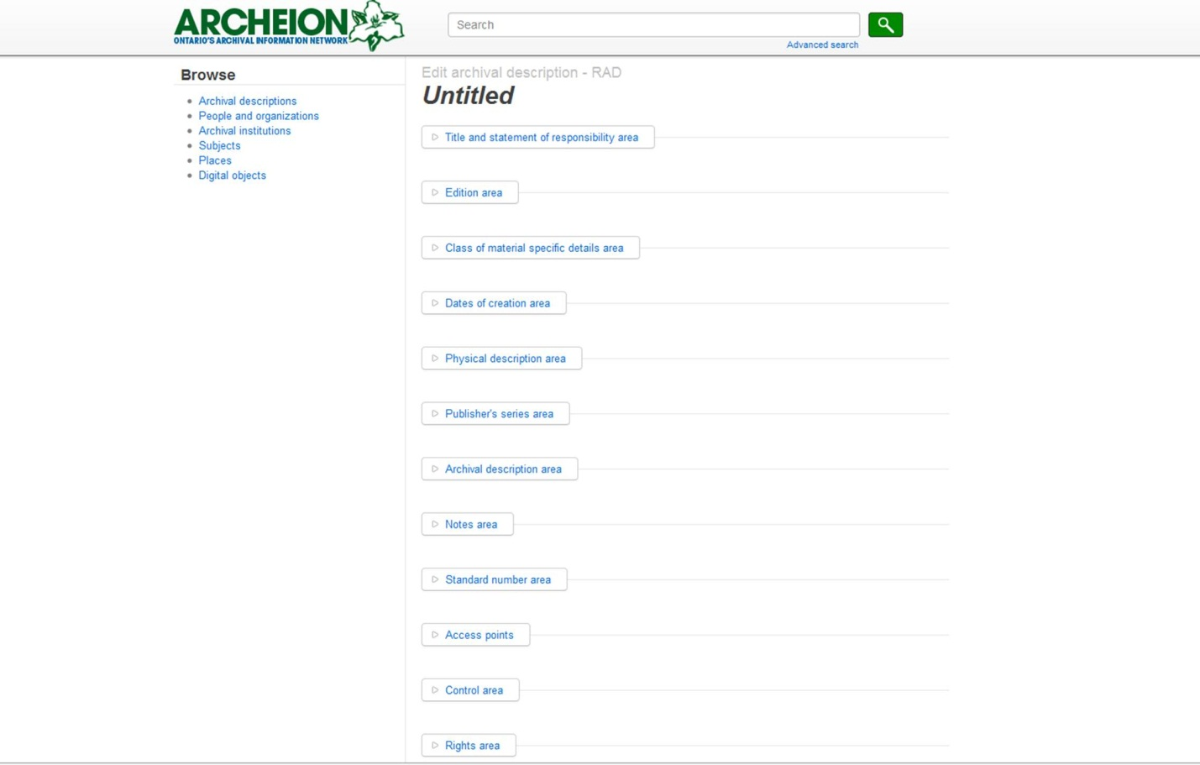
Most of the headings are taken from the Rules for Archival Description (RAD). Clicking on the title of each heading expands the section so that you can complete your description by filling out the different fields. Note that not all of the fields need to be completed in order to make an archival description which complies with the RAD standard. In this guide we will focus on the most commonly-used RAD fields.
You do not have to complete your description in one sitting: save your work at any time by clicking the 'Create' button at the bottom of the editing window. You can come back to it later.

Title and statement of responsibility area (RAD 1.1B)
For most archival descriptions the title is usually supplied by the archivist creating the description, based on the name of the creator and the nature of the material being described. This goes in the field headed 'Title proper'.

Title proper (RAD 1.1B3) [Required]
Enter the name of the person, family, or corporate body responsible for the creation of the records, followed by the word fonds. If the unit being described is an artificially accumulated collection, use the word 'collection' instead of fonds.
Examples:
Anthony Adamson and Marion MacRae fonds
Frederick Hagan fonds
Kingston General Hospital photograph collection
Proctor family fonds

Level of Description (RAD 1.0A4) [Required]
RAD states that the level of description should be made distinct by layout or typography. In Archeion, the level of description needs to be made explicit. Choose from one of the options in the drop-down menu. The choices are: Record Group, Fonds, Collection, Sous-fonds, Series, Subseries, File or Item. For a top-level description, choose either Fonds or Collection.

Repository [Required]
Start typing the name of your repository and click on it to fill this field. This ensures that your archival description and repository record are linked.

Identifier
If your repository has a unique reference code associated with the material you are describing (e.g. an accession or call number), enter that here.

Edition area (RAD 1.2)
This area is used in item-level descriptions only, for recording information about items which exist in two or more versions.

Class of material specific details area (RAD 1.3)
This area is used for describing particular aspects of maps, architectural materials and postage stamps.

Dates of creation area (RAD 1.4)
This is an important area: it is where creators of archives are linked with the archival description and where the dates of the material are recorded.

Actor name (ISAAR-CPF 5.1.2) [Required]
Used for the creator of the archive: can be a person, family or corporate body. Start typing the name of an authority record here and click on the name to enter it. Be sure to click on the name when it appears in the list: if you just type the name and enter it, you will create a new authority record with the same name! This field is required in order to link your archival description to the authority file which describes the creator of the record.
If there is more than one creator of the material you are describing, you will need to add another creation field after submitting the first one.

Place (RAD 1.4C1)
This field is used with printed materials for the place of publication

Date (RAD 1.4B) [Required]
Give the date(s) of creation of the unit being described either as a single date, or range of dates (for inclusive dates and/or predominant dates). Always give the inclusive dates. When providing predominant dates, specify them as such, preceded by the word predominant.
Examples:
1890
1934-1955
[ca. 1875]-1954
1812-1903, predominant 1845-1867

For uncertain or probable dates, use the following table as a guide for formatting the dates:
[1867?] | probable date
[ca. 1867] | approximate date
[before 1867] | terminal date
[after 5 Jan. 1867] | terminal date
[1892 or 1893] | one year or the other
[between 1915 and 1918] | use only for dates fewer than 20 years apart
[197-] | decade certain
[186-?] | probable decade
[17–] | century certain
[17–?] | probable century

Archeion will automatically fill in the 'Start' and 'End' fields for you. You might need to check these if you have used brackets or question marks or multiple dates in the date field.

Physical description area (RAD 1.5B) [Required]
At all levels, record the extent of the unit being described by giving the number of physical units and their nature. RAD gives the option of using the phrase 'and other material' where there are several types of material in a fonds or collection, but this is not recommended for Archeion contributors. Record all the different types of materials found, starting each on a new line. Use metric measurements.
Examples:
ca. 200 photographs
50 maps
21cm of textual records
102 posters : silkscreen ; 60 x 90 cm, 40 x 60 cm and smaller

Publisher's series area (RAD 1.6)
Used for published materials when describing an item which forms part of a series.

Archival description area (RAD 1.7)

Administrative history/Biographical sketch (RAD 1.7B)
This field is automatically filled in with information taken from the History field of the authority record for the creator of the material (ISAAR-CPF 5.2.2). To edit this field, you need to edit the separate authority record (refer to section 2 of this guide).

Custodial history (RAD 1.7C)
Use this field to record the changes of ownership of the archival materials, if known, since their creation. If the records were received directly from their creator, record this information under 'Immediate source of acquisition' in the Notes area.

Scope and content (RAD 1.7D) [Required]
Use the first sentence of this section to give an overall summary of the material.
For the scope of the unit being described, give information about the functions and/or kinds of activities generating the records, the period of time, the subject matter, and the geographical area to which they pertain.
For the content of the unit being described, give information about its internal structure by indicating its arrangement, organization, and/or enumerating its next lowest level of description. Summarize the principal documentary forms (e.g., reports, minutes, correspondence, drawings and speeches).
Examples:
Fonds consists of Anthony Richmond's records pertaining to his career as a scholar and includes his research files, professional files, manuscripts, as well as his personal files.
----
The collection consists of records of various private businesses which operated in Hastings County, Ontario, which were gathered as a unit by the Hastings County Historical Society. Various kinds of activities and occupations are represented: collection of duties; public utilities; loan; general merchants; grocery; temperance; insurance; engineering; surveying; railway…

Notes area (RAD 1.8)
All the fields in this section are optional, with the exception of Language, Restrictions on access and Finding aids.

Physical condition (RAD 1.8B9a)
Note anything about the physical condition of the material being described that affects the clarity or legibility of the records. Also consider noting if the material has suffered mould damage, even if it does not affect the legibility of the records, as a warning to potential users.

Immediate source of acquisition (RAD 1.8B12)
Enter information about the donor from whom you obtained the records. Only information about the holder of the record immediately prior to their transfer to the archives should be recorded in this field.

Arrangement (RAD 1.8B13)
Not used in Archeion: the Scope and content field (RAD 1.7D) should be used for information about arrangement of the material.

Language (RAD 1.8B14) [Required]
Start typing the name of the language of the archival materials and select it from the drop-down list. You can add as many languages as you need. Enter the predominant language(s) first.

Script (RAD 1.8B14)
If your materials include items in non-roman scripts (e.g. Arabic, Bengali), enter them here. Start typing the name of the script and select it from the drop-down list. You can add as many scripts as you need.

Location of originals (RAD 1.8B15)
If the records being described are copies and you know where the original records are located, enter that information here. Put in a link to online materials, if appropriate. You do not need to put HTML coding around the link: just paste the link in and it will automatically be turned into a hyperlink in Archeion.

Availability of other formats (RAD 1.8B15b)
If the records being described are available in another format, record that information here. If any materials are online, you can put a link to them here.

Restrictions on access (RAD 1.8B16a) [Required]
Enter information about any applicable restrictions on researchers' ability to view the material. Be as precise as possible in the context of the fonds or collection. If there are no restrictions, write 'Open'.

Terms governing use, reproduction, and publication (RAD 1.8B15b and c)
Record any restrictions on the use and reproduction or publication of the material here. List any information relating to copyright, literary rights, patent rights or donor terms that may restrict use or reproduction of the records.

Finding aids (RAD 1.8B17) [Required]
Enter here information on any finding aids available for this fonds or collection, including lists, catalogues, and inventories. If a finding aid is online, you can put a hyperlink to it here. You do not need to put HTML coding around the link: just paste the link in and it will automatically be turned into a hyperlink. If there are no finding aids, write 'None'.

Associated/related material (RAD 1.8B18 and 1.8B20)
Note any fonds in your own or in other institutions that are related by provenance to the records being described. You can paste links to online descriptions, if appropriate. You do not need to put HTML coding around the link: just paste the link in and it will automatically be turned into a hyperlink in Archeion.

Accruals (RAD 1.8B19)
If any more material is expected to be added to this fonds, record the information. This field can also be used if the fonds is closed by stating 'No further accruals expected'.

Standard Number area (RAD 1.9)
Used only at item level for published materials with ISBN or ISSN numbers.

Access points (RAD 21) [Required]
Access points, or index terms, are a way of summarizing the important aspects of the archival materials you are describing. In Archeion, you can add subjects, places and names as index terms.
The name of the creator of the materials will automatically be added as an access point. Archeion has drop-down lists of names from which you can select appropriate terms for the materials you are describing.
Subject terms currently available in Archeion are:
Agriculture
Arts and culture
Buildings and structures
Business and commerce
Children and youth
Communications
Community life
Cultural groups
Education
Environment
Events and celebrations
Exploration, discovery and travel
Family and personal life
First nations
Geographic features
Government
Health and social services
Industries
Labour
Land, settlement and immigration
Law and justice
Military
Natural resources
Organizations
Politics
Religions
Science and technology
Sports, recreation and leisure
Transportation and utilities
Women

Place names form a hierarchy, with a detailed gazetteer for Ontario place names and general headings for other provinces and other continents:
Africa
Alberta
Antarctica
Asia
Australia
British Columbia
Canada
Europe
Manitoba
New Brunswick
Newfoundland and Labrador
Northwest Territories
Nova Scotia
Nunavut
Ontario (2737)
Prince Edward Island
Quebec
Saskatchewan
South America
United States of America (USA)
Yukon Territory

Ontario has been subdivided into counties, districts and regions which contain the names of individual Ontario towns, villages and other inhabited places. Start typing the name of the place you wish to enter as an access point and then select it from the drop-down list.
If you are adding a place in another province or territory, just put the name of the province. If it relates to Canada in general, just use Canada. If it is a place in the USA, just put United States of America. If in another continent, use the name of the continent as your access point.
People, families and organizations can be added as subjects in the same way as you add other authority records. Consult Section 2 of this guide for step-by-step instructions on how to create authority records. Once you have created an authority record for an individual, family, or organisation, typing the first few letters will bring up a list containing that name which you can click to add to your access points.

Control area
The control area relates to the creation and maintenance of the description you have created. None of these fields are essential for Archeion descriptions, but they may prove useful for your repository for administrative purposes, for example for recording information on creation and revisions of descriptions.

Rights area (PREMIS <rights>)
This area allows you to specify rights. It is principally designed to be used at the level of individual items, to record details of copyright, licenses, legal constraints, donor restrictions and institutional policies in relation to digital objects. This area is unlikely to be used at fonds- or collection-level within Archeion.

Administration area
This part of the template controls whether your description is draft (and therefore unavailable to users of Archeion) or published. The status can only be changed by an individual with publication rights for your repository.

Adding sous-fonds, series, files or items
Archeion supports the description of materials within a fonds or collection. This means that you can create full hierarchical finding aids, right down to the level of individual items, if you wish to.
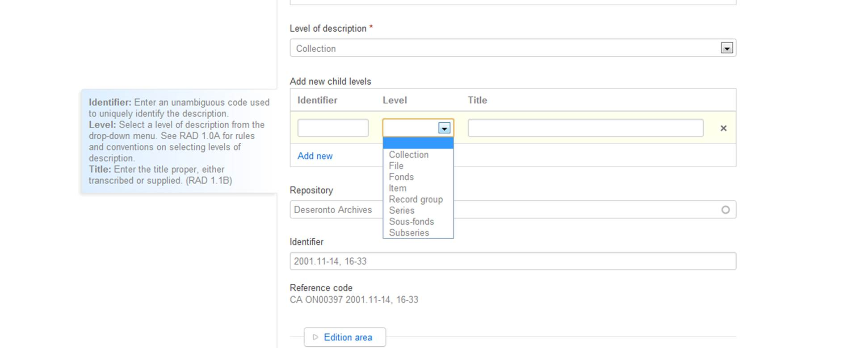
From your fonds or collection description, add another level of description in the Title and Statement of Responsibility Area. Go to the 'Add new child levels' section, pictured here:

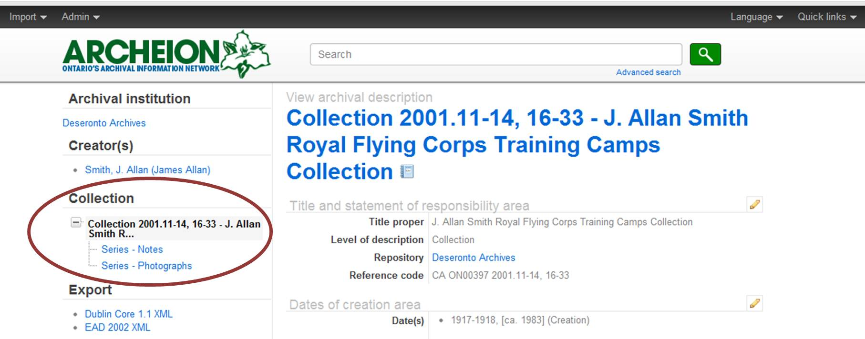
Choose the name of the level you wish to add (usually series at this point, but could be sous-fonds or file). Give the lower level of description an appropriate title and, if it has one, an identifying number. You can add more than one level at once. Then click 'Save' at the bottom of the screen to create your lower level description. This action will return you to a view of the fonds or collection description. On the left of the screen you will see that the lower level of description is now represented in a tree-structure:

To edit the lower level of description, click on the title. This will bring up the RAD editing screen and you can enter relevant information for that level of description. You do not need to enter the name of the repository or the name of the creator, as this information is already in the fonds or collection description. Enter only information which is appropriate for the material you are describing.
New child levels can be added to any existing level of description.

Adding digital objects (images, audio or video)
You can attach digital objects to any level of description; for example you could attach a photograph of an individual to the description of their fonds or collection. This option is, however, most often used when describing materials at the item level.
Once you have described the item which you would like to associate a digital object with, click on one of the two buttons circled here:
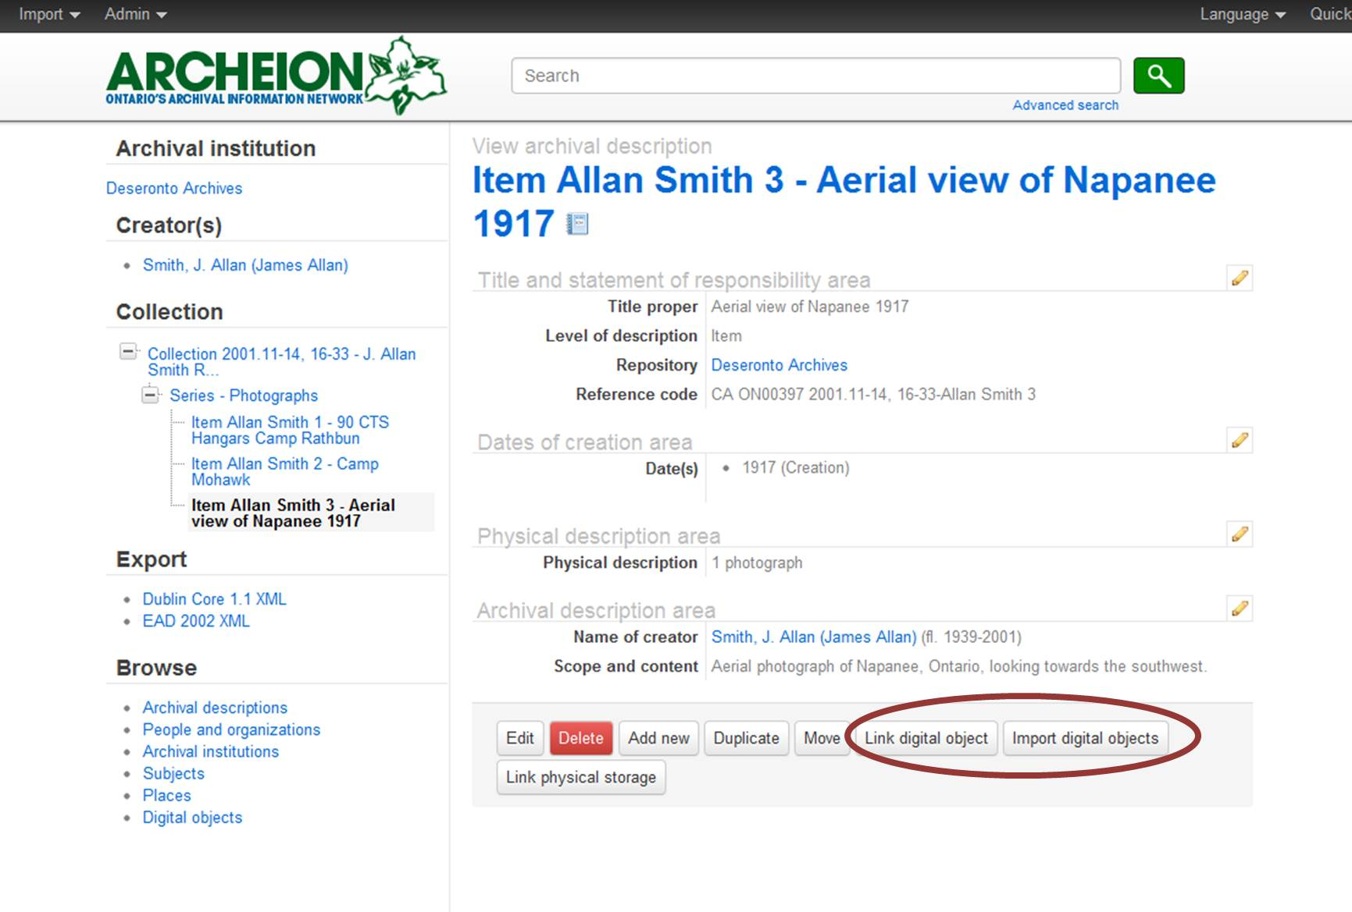
If you want to link to a digital object stored somewhere on the Internet, click the first button, Link digital object and then enter the web address of the item. If you want to upload an object from your local system to be stored on Archeion's site, click Import digital object and then find the file on your system.
The difference between linking a digital object and importing it is that importing an object takes up more space on the Archeion server. The AAO is paying for one gigabyte of storage space for each institutional member of the Association in Archeion. If you need more than one gigabyte, please contact the Archeion Coordinator at archeion@aao-archivists.ca, who will arrange for you to be invoiced by Artefactual Systems for the additional space. The cost of this is currently $0.99 per gigabyte per month.
Once the file has been uploaded or linked, the display will show the digital object:
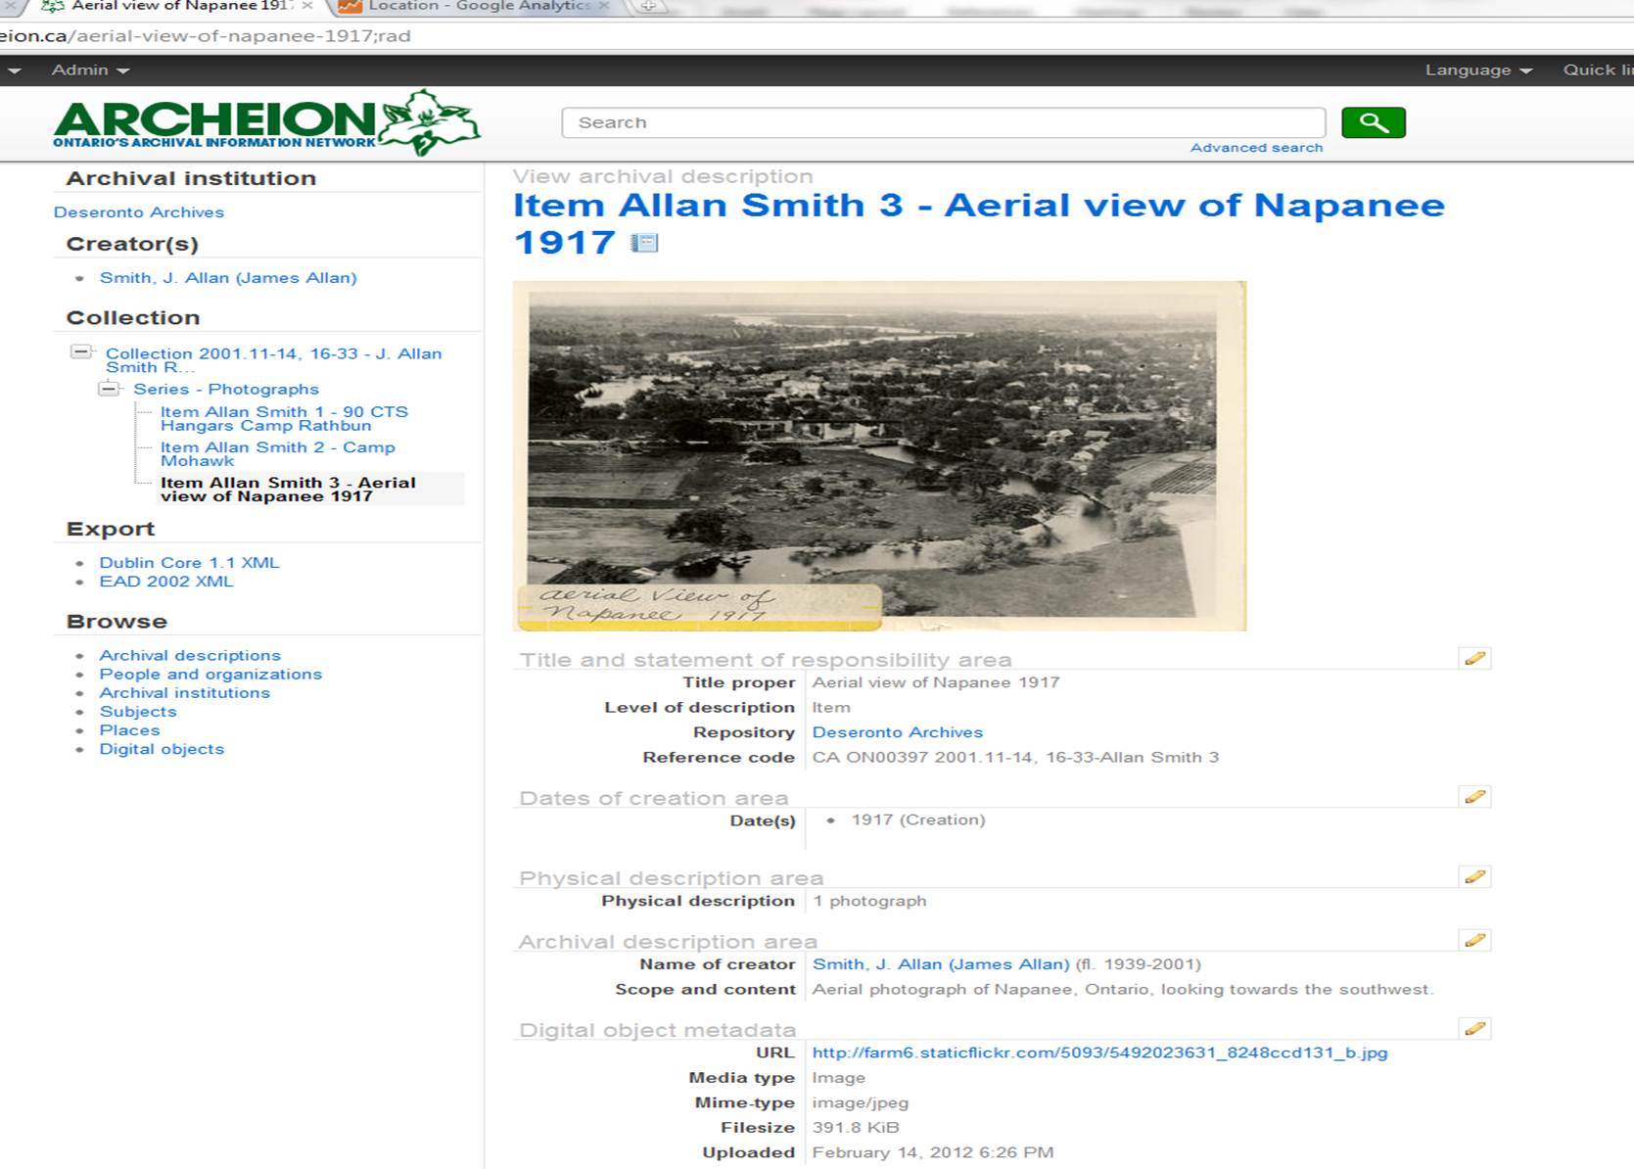
If you link a number of images to a fonds or collection a slider graphic will appear:
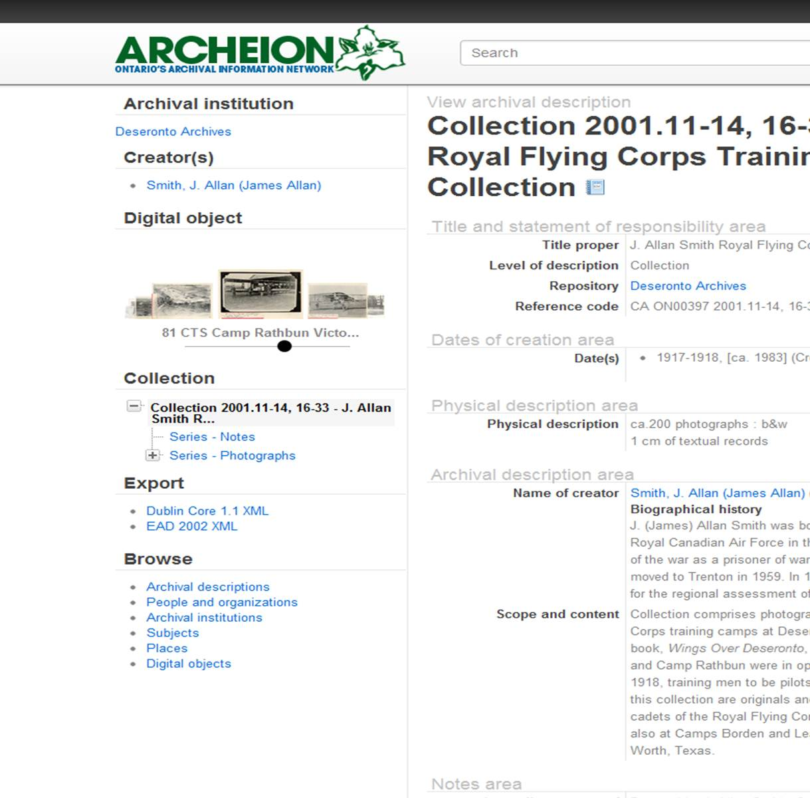

International Standard for Describing Institutions with Archival Holdings, http://www.ica.org/download.php?id=1657
International Standard Archival Authority Record for Corporate Bodies, Persons and Families http://www.icacds.org.uk/eng/isaar2ndedn-e_3_1.pdf
Rules for Archival Description (the Canadian standard for describing archival holdings) http://www.cdncouncilarchives.ca/RAD/RADComplete_July2008.pdf

